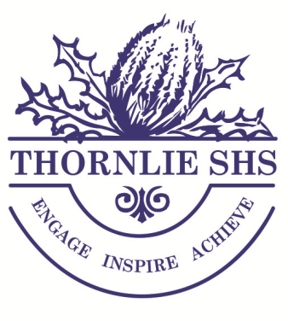
Year 10 Subject Costing Sheet 2018

Compulsory Subjects

English (10EN) | $30.00
Mathematics (10MA) | $30.00
Science (10SC) | $30.00
Humanities (10HASS) | $30.00
Physical Education (10PE) | $15.00
Health Education (10HE) | $17.00

Electives
* indicates High Cost Option (Charge)
Languages |  |  | Physical Education
Italian (10ITA) | $15.00 |  | Girls Just for You (10GJY) | $95.00*
Japanese (10JSL) | $15.00 |  | Netball Program (10NET) | $80.00*
 |  |  | Outdoor Education (10OED) | $85.00*
Science (Elective) |  |  | Physical Recreation (10PR) | $95.00*
STEM (10STEM) | $145.00* |  | Soccer (10SOC) | $65.00*
 |  |  | Specialised Rugby (10RDP) | $100.00*
Technologies |  |  | The Arts
Child Care (10CC) | $ 45.00 |  | Media (10MED) | $35.00
Computer Engineering (10CE) | $ 50.00* |  | Dance (10DAN) | $70.00*
Computer Programming (10CP) | $ 45.00* |  | Graphic Design (10GD) | $65.00*
Engineering Systems (10ES) | $ 62.00* |  | Hip Hop Dance (10HIP) | $70.00*
Fashion Design (10FD) | $ 60.00* |  | Instrumental Music (10IM) | $50.00*
Intro Accounting & Finance (10IAF) | $ 32.00 |  | Piano Keyboard Music (10PKM) | $60.00*
Materials – Metals (10MM) | $80.00* |  | Visual Arts (10VA) | $65.00*
Materials - Wood (10MW) | $80.00*
Spotlight on My Food (10SMF) | $105.00*
Technical Graphics (10TG) | $ 33.00

