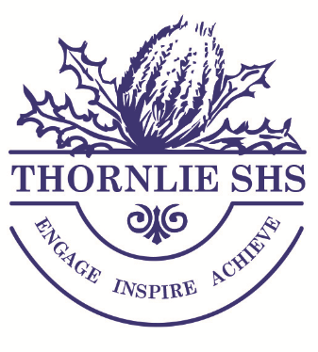

Thornlie Senior High School
Guide to Year 11 Studies

INFORMATION FOR PARENTS OF STUDENTS ENTERING
YEAR 11 AT THORNLIE SENIOR HIGH SCHOOL

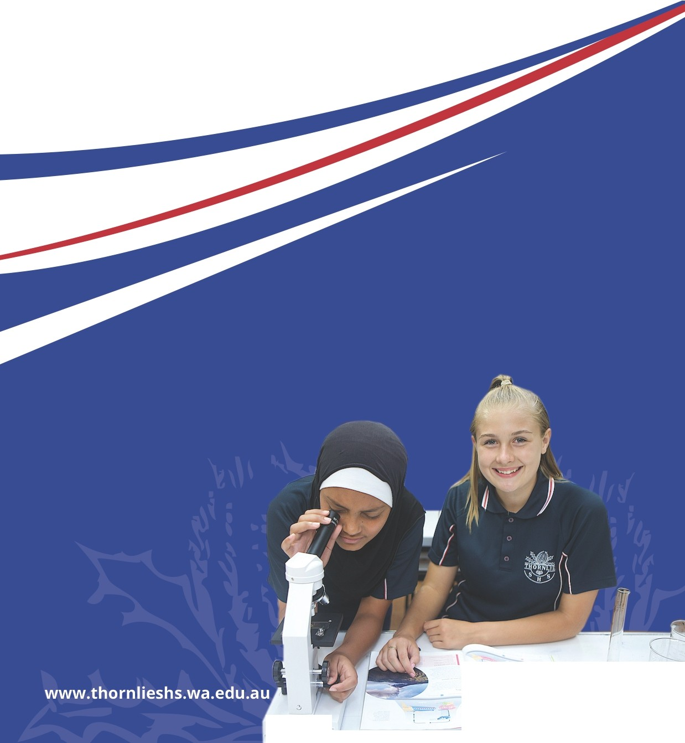

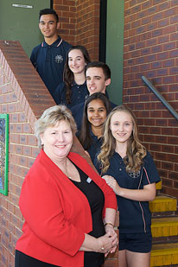

Thornlie Senior High School

Our Vision – Engage Inspire Achieve

Thornlie Senior High School students fulfil their aspirations working in an environment that emphasises the importance of respectful relationships and the achievement of personal best.

High Performance – High Care

Dear Students and Parents/Caregivers

Senior School Choices for Students at Thornlie SHS

Thornlie Senior High School has a proud history established over its more than 49 years of service to our students, of providing challenging and engaging senior secondary pathways of study.

This document will provide you with the full range of Year 11 and 12 ATAR, General, VET and Big Picture Courses available for our students to select from as they work towards preparing to achieve their career goals.

At the end of 2021, Year 10 Thornlie students will enter the next phase of their secondary education and progress into Senior School studies. Their focus will be on participating in Year 11 and 12 Courses that will provide the foundation for their move into university, training or the workplace at the end of their secondary education.

In the Senior Years students are carefully monitored and supported by their Year Coordinator, Deputy Principal - Senior School and Teachers to ensure they achieve their best possible grades. This support will ensure they are well prepared to follow their career aspirations on their successful completion of Year 12.

I invite you to explore this handbook and discover the broad array of courses, various modes of study and different campus/work options on offer. These offerings have been carefully designed to meet your needs and assist you to achieve your aspirations.

Over the coming months, we will work directly with you to assist you in selecting an academic program that is relevant, fulfilling and challenging.

I trust that you find this handbook both useful and informative.

We look forward to working through this important decision making and course selection process with you.

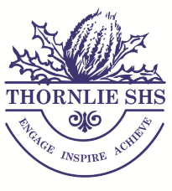
Donna McDonald
Principal

HOW TO USE THIS BOOKLET

This booklet, and the others enclosed in your package, present a summary of the rules for achieving a WACE in 2023.

This book details the courses available and other vital information necessary to make good choices. It does not stand-alone. Advice and information is available from the Deputy Principals, Year Coordinators, Careers Centre and our Course Advisory Team.

Course Advisory Team
Senior School Deputy Mr David Norcliffe
Manager of Operations Mr Paul Beecham
VET Coordinator Mrs Linley Stewart

Additional Course Advisors
- Mrs Alisha Bayliss
- Mr James Lamont
- Mr Jason Turner

This Guide to Subject Selection identifies the selection requirements for Year 11 and 12 students, while a number of pages contain information regarding WACE requirements and sources of additional career information.

All Year 10 (Year 11 in 2022) students will work with a Course Advisory Teacher to select the best combination of courses for their chosen career pathway.

INTRODUCTION
This handbook has been written to provide information to parents and students to enable them to make informed decisions about directions for Year 11 and 12 in 2022/2023.

Changes to senior school secondary education are ongoing as the school system adjusts to changes to the WACE requirements, changes in the employment scene as well as increasing competition for university and TAFE places.

Please note that the information contained in the booklet is current as of May 2021. If parents/guardians or students need to find out further developments they can access the School’s Curriculum and Standards Authority website – http://www.scsa.wa.edu.au/ - to keep abreast of any changes that may occur.

CHOOSING WISELY
Students must consider choices wisely. All senior school students should ask themselves the following questions when selecting a course:
- What occupations are of interest?
- Which subjects do I need for the occupations that interest me?
- What are my subject pathways?
- What am I good at? What subjects do I find difficult?
- What are my current levels of achievement?

Forward planning is essential if you are to make the most of your opportunities. Take the time to access and research quality career information. It is very difficult to change subjects once the timetable has been set. The following guidelines may be helpful:

- Relate subjects to current career information.
It is helpful to have a few career choices in mind before choosing subjects. If you are unsure about this at present, seek help in trying to choose a course that will keep several career options open to you.

- Find out about the full list of subjects the school offers.
Check out each subject carefully. To do this it will be necessary to:
- Read the subject descriptions in this booklet;
- Talk to teachers and the Head of Learning Area for each subject;
- Talk to students currently enrolled in the subject; and
- Read the VET Courses and Policies booklet.

- Decide on the subjects that suit your requirements and abilities.
Students need to remember that all ATAR courses will have an examination that must be taken if you wish to qualify for direct university entrance. Any General course will not have an examination but students need to remember that results for all units can count towards TAFE entry. Remember TAFE is a valid pathway to university and careers.

- Be prepared to ask for help.
There are many people around to talk to –
- parents
- career education teachers
- TAFE and University admission officers
- Vocational Education & Training (VET) Program Coordinator
- Careers Reference Centre staff

Additional information may be obtained from http://www.education.gov.au/job-guide

UNDERSTANDING YEARS 11 & 12

Students commencing Year 11 at Thornlie SHS in 2022 have a choice of two pathways –General or ATAR. Students are advised to choose the pathway that best suits their intended post-school destination.

All students should enrol in the Course which best matches their previous level of achievement. Below is an outline of the two pathways and their possible subject combinations.

Your child’s current teachers can recommend which course is best suited to them.

Please note that the subjects chosen for study in Year 11 must continue to be studied in Year 12.

PATHWAYS
- General Pathway – To gain entry to TAFE, Apprenticeship or Employment

Students who are not studying the ATAR pathway must study the General pathway. Students studying the General pathway at Thornlie SHS must enrol in one Certificate course. For the other 5 subjects it is recommended that students choose General subjects.

Certificate Pathway students should ideally combine their certificate course with General subjects only, however selecting one ATAR course is permitted if their intended career requires. For example, students wishing to become an Electrician will need to study ATAR Maths (Provided they obtain their teacher’s recommendation)

Possible subject combinations:
- 1 CERTIFICATE COURSE and 5 GENERAL subjects
- 1 CERTIFICATE COURSE, 4 GENERAL subjects and 1 ATAR subject

- ATAR Pathway – To gain direct entry to university
To determine a student’s ATAR their 4 highest scoring subjects are used. For this reason a student intending to obtain an ATAR must study at least 4 ATAR subjects in Years 11 & 12.

Students may choose to have a “back-up” subject (in case they do not perform well in one of their exams) and select 5 ATAR subjects. This is a wise decision, however students need to realise that 5 ATAR subjects presents more work than 4 ATAR subjects.

ATAR students will also need to study one Certificate Course, which will assist in achieving TAFE entry should they choose that option.

Possible subject combinations:
- 4 ATAR subjects, 1 GENERAL subject and 1 CERTIFICATE COURSE*
- 5 ATAR subjects and 1 CERTIFICATE COURSE*
- 6 ATAR subjects (for those who select maths Specialist)

* Please note: ATAR students selecting Certificate II in Community Services or Hospitality will be required to undertake the Workplace Learning requirements of these courses at the end of Year 11.

The booklet outlines the wide range of courses that our school, Thornlie SHS, offers to Year 11 Students.

We are a fully comprehensive senior school with Certificate, Foundation, General and Endorsed courses available. For ease of identification, courses have been highlighted as the following:

Certificate
Foundation
General
Endorsed
ATAR

TERTIARY ENTRANCE REQUIREMENTS
UP-TO-DATE INFORMATION WILL BE PUBLISHED ON THE TISC WEBSITE IN JULY 2021.
To be considered for university admission as a school leaver, an applicant must -
- meet the requirements for the Western Australian Certificate of Education (WACE) as prescribed by the Schools Curriculum and Standards Authority,
- achieve competence in English as prescribed by the individual universities,
- obtain a sufficiently high Australian Tertiary Admission Rank (ATAR) for entry to a particular university and/or course; and
- satisfy any prerequisites or special requirements for entry to particular courses.

Portfolio Pathway University
In addition to the requirements outlined above, some universities offer an additional pathway for entry by school leaver students.
Detailed information about the requirements for the Portfolio Entry Pathway may be obtained from each individual university’s website.

Full details regarding individual university entrance requirements and processes are available from the TISC website: www.tisc.edu.au. The University Admission 2022 booklet will soon be available on the website, but please note that is it subject to change.

University Application Procedures
Information about applying to the universities and admission to undergraduate courses will be sent to Year 12 students at their schools in August. Application will be via TISC's website.
The closing date for applications without incurring a late fee is normally the end of September. Offers of admission are made by the universities in the second half of January and in early February.

Any further information about application procedures may be obtained from TISC. Enquiries about mid-year entry, external studies and particular course requirements should be directed to the university concerned.
Applications need to be made through TISC when the applicant is:
- an Australian citizen,
- a New Zealand citizen,
- Approved/granted Australian permanent resident status.
International students do not fit these categories and will need to apply directly to the International Office at the relevant university.
Full details regarding individual university entrance requirements and processes are available from the TISC website: http://www.tisc.edu.au

TRAINING WA STATE TRAINING PROVIDERS (including TAFE)

State Training Providers (STP) offers courses for vocational education and training, apprenticeships and traineeships, support for workplace learning and courses for business and industry.

To gain entry into a State Training Provider (STP), applicants need to meet the entrance requirements for the chosen course. Where a course is deemed to be competitive, applicants are required to meet both the entrance requirements and selection criteria. Selection criteria will focus on secondary education achievement, skill development, previous qualifications and workplace learning (paid or unpaid). Courses that require selection criteria to be met will clearly indicate this below the entrance requirement information.
The Career Centre (Perth City Centre)
GPO Building : Level 7
3 Forrest Place
Perth WA 6000
Email: career.centre@dtwd.wa.gov.au
Phone: 13 23 98 or 9224 6500

Students who are interested in applying for State Training Provider (STP) courses are strongly advised to access the latest information from www.tafechoices.com. Students will find detailed information on the website, but if more information or clarification is needed, then contact The Career Centre.
APPRENTICESHIPS AND TRAINEESHIPS
Students can begin a training qualification in Years 11 and 12 at the same time as completing the Western Australian Certificate of Education (WACE) through one of TWO programs: School Based Apprenticeship or School Based Traineeship Students generally attend school for three days and spend one day in the workplace and one day at a registered training organisation.

Apprenticeships and traineeships combine practical experience at work with structured training that leads to a nationally recognised qualification. If students are interested in technical trades such as bricklaying or cabinet making, then they would consider an apprenticeship. Traineeships are usually in non-trade areas such as hospitality, business, manufacturing and health.
- School Based Apprenticeships:
School based apprenticeships allow students in Years 11 and 12 to start an apprenticeship while still at school. Students enter into a legal binding contract between the employer, the student and parent/guardian to complete the apprenticeship.

Apprentices enter into a contract with an employer who teaches all aspects of a trade. Apprenticeships are structured programs where students learn on the job and attend training at a Training WA (TAFE) college or another registered training provider.

- School Based Traineeships:
School based traineeships allow students in Years 11 and 12 to develop skills and get paid while they prepare for a career in the workforce. Students work towards secondary graduation and an industry recognised qualification.

Students enter into a legally binding contract between the employer, the student and parent/guardian to complete the traineeship. Trainees enter into a contract with an employer in order to gain hands-on skills and work experience while earning a wage.

- Aboriginal School Based Training:
Aboriginal School Based Training helps students start an apprenticeship or traineeship whilst attending school.

As an apprentice or trainee, students are employed by a group training organisation, which places them with host employers. Students spend time in the workplace with the host employers and time training with the training providers. Students are paid and gain skills for the real world.
Find out more by going to: http://www.dtwd.wa.gov.au/employeesandstudents

CAREERS AND EDUCATION WEBSITES
The following websites may help students to investigate and determine their post-school options.

- Apprenticeships and Traineeships
www.dtwd.wa.gov.au.
- Australian Defence Force Academy
www.defencejobs.gov.au
- Australia wide job search
www.jobsearch.gov.au
- Career, employment, training information in Western Australia
www.careercentre.dtwd.wa.gov.au
- Career research
www.careersonline.com.au
- Centrelink
www.humanservices.gov.au
- Curtin University
www.curtin.edu.au
- Edith Cowan University
www.ecu.edu.au
- Education Services Australia
http://www.esa.edu.au
- Job Resources Australia
www.education.gov.au/youth
- Murdoch University
www.murdoch.edu.au
- My Future
www.myfuture.edu.au
- Tertiary Institutions Services Centre
www.tisc.edu.au
- University of Notre Dame
www.nd.edu.au
- University of Western Australia
www.uwa.edu.au
- Vacancies Australia wide
www.seek.com.au
- Western Australian Government (go to ‘Education and Training’)
www.wa.gov.au

CERTIFICATE COURSES

VOCATIONAL EDUCATION & TRAINING (VET)

In 2022, Thornlie Senior High School as a Registered Training Organisation, will be offering Vocational Programs in many different areas. Students who are part of these programs will be involved in regular work placement.

Enrolment in a VET program provides students with the opportunity to gain additional qualifications that are nationally recognised by employers, TAFE and other training organisations. Many of these programs include nationally recognised Units of Competency, which, if successfully completed, can lead to Certificate I, II or III qualifications, accredited under the Australian Qualifications Framework.

Vocational Education and Training (VET) in Schools program are delivered as part of a broad, general education that combines study towards the Western Australian Certificate of Education (WACE) with a nationally recognised VET qualification within the Australian Qualification Framework (AQF).
Thornlie Senior High School is committed, through its administration and VET staff, to offer the best and most comprehensive range of subjects available.

Thornlie Senior High School gained status as a Registered Training Organisation (RTO) in 2005.
As an RTO, Thornlie SHS delivers National Competencies which are recognised by TAFE and industry. Competencies completed will attract TAFE exemption and gain selection points for TAFE entry.

Full qualifications are offered as follows by Thornlie SHS as a Registered Training Organisation:

- BSB20120 Certificate II in Workplace Skills
- CHC22015 Certificate II in Community Services
- CUA20113 Certificate II in Dance
- CUA20215 Certificate II in Creative Industries
- CUA20715 Certificate II in Visual Arts
- ICT20120 Certificate II in Applied Digital Technologies
- MEM20413 Certificate II in Engineering Pathways
- SIS20115 Certificate II in Sport and Recreation
- SIT20316 Certificate II in Hospitality

Trading as an RTO (Registered Training Organisation), Thornlie SHS is required to supply all students with extended information on Courses and Policies before entry into the course

The Vocational Education and Training Programs 2022 Handbook contains additional information on Vet Courses and Procedures.

In order to complete the requirements of all certificates, students must attend a minimum of 90% of scheduled classes. Students who choose to study this course in Year 11 must continue the course in Year 12.

Certificate II in Community Services (Childcare) and Certificate II in Hospitality have a compulsory work-based component where students will be required to attend a workplace relating to their certificate.

A range of learning strategies in a variety of learning environments will be used in order to cater for differences in learning styles, learning interests and needs, and variations in learning opportunities (including online). Students will be provided with further information in the Learning and Assessment Strategy in each course package.

At Thornlie SHS students are only permitted to study one Certificate course. This course can contribute up to four of the 20 units you need to achieve your WACE.

WORKPLACE LEARNING (ADWPL)
ENDORSED PROGRAM

Workplace Learning (ADWPL)
The following students must all do Workplace Learning:

- Students enrolled in Certificates in VET
- Students enrolled in at least four General courses

Workplace Learning is an endorsed program, which involves training and assessment in a real workplace, providing Year 11 and 12 students with supervised learning activities. A skills journal requiring ten questions is to be completed after each 55 hour block.

Achievement of 55 hours of Workplace Learning provides one-unit equivalent towards the WACE completion requirement.

Students will attend on the job training for 4 x two week block during Years 11 &12. This will provide the opportunity to achieve two units towards WACE each year.

Completion requirements
To achieve one program of Workplace Learning students must have:
- completed a total of 55 hours in the workplace relating to their certificate
- maintained a logbook documenting workplace attendance and tasks undertaken
- completed the Workplace Learning Skills Journal after each 55 hour block

CERTIFICATE COURSES

For each of the Certificate Courses included in the following pages, please be aware that:
- Each qualification is subject to change due to continuous Training Package Reviews.
- Students are enrolled in the same certificate course across Year 11 and 12
- Students will not be allowed to change certificate courses after Week 3 Term 1 in Year 11

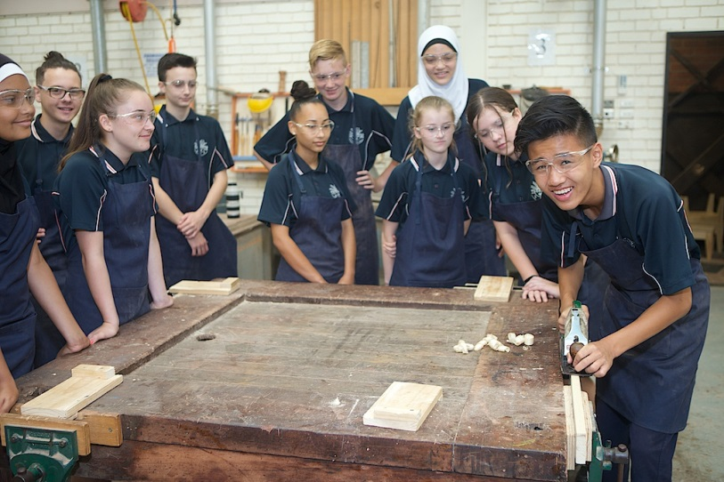

BSB20120: CERTIFICATE II IN WORKPLACE SKILLS (DBUS)
CERTIFICATE SUBJECT
Qualification Description
This qualification reflects the role of individuals in a variety of entry-level Business Services job roles. This qualification also reflects the role of individuals who have not yet entered the workforce, and are developing the necessary skills in preparation for work. These individuals carry out a range of basic procedural, clerical, administrative or operational tasks that require self-management and technology skills. They perform a range of mainly routine tasks using limited practical skills and fundamental operational knowledge in a defined context. Individuals in these roles generally work under direct supervision.

Entry Requirements
There are no entry requirements for this qualification.
Job role
- Administration Assistant / Clerical Worker
- Data Entry Operator
- Information Desk Clerk / Office Junior
- Receptionist.

Suggested Home Study Commitment
2 hours per week.

Course Information |  |  | Qualification Rules
Year 11/12 | DBUS/EBUS | BSB20120 Certificate II in Workplace Skills | Qualification Rules  Total number of units = 10  5 core unit plus  5 elective units

CHC22015: CERTIFICATE II IN COMMUNITY SERVICES (DCFCC)
CERTIFICATE SUBJECT

Course Description
This course is an entry level qualification designed for students who are looking for skills for working with children in the community. Through this course, students will study the basics of working efficiently with children from birth to 12 years of age, however the major focus of study is on 1 – 6 years of age. This qualification may be used as a pathway into Certificate III in Community Services or Early Childhood Education and Care.

Course Outline
In order to complete this course, the student must complete a total of nine (9) Units of Competency. Five (5) of these are compulsory core units and the remaining four (4) are elective units chosen by the teacher delivering the content. Students must also complete work placements during the course.
Entry Requirements
There are no entry requirements for this qualification.
Suggested Home Study Commitment
2 hours per week

Course Information |  |  |  | Qualification Rules
Year 11/12 | DCFCC/ECFCC | Child Care | CHC22015: Certificate II in Community Services | Total Number of Units=9  5 Core Units plus  4 Elective Units

CUA20113: CERTIFICATE II IN DANCE (DDAN)
CERTIFICATE SUBJECT

Prerequisites
Nil. However, having studied Dance in lower school is preferred.

Course Description
This qualification is a preparatory qualification that can be used as a pathway into specialist Certificate III qualifications within the live performance industry.
This course involves both practical and theoretical studies of Dance which will be divided evenly into two (2) periods of each. This will include students receiving tuition from outside experts in a range of different dance genres throughout the course. Students will spend a proportion of their learning in a classroom, covering the theoretical components of the Dance course.

Each unit is defined with a particular focus and a selection of learning contexts through which the specific unit content can be taught and learnt.

Course Outline
In order to complete this course, the student must complete a total of ten (10) units. Seven (7) of these are compulsory core units and the remaining three (3) are elective units chosen by the teacher delivering the content.

Suggested Home Study Commitment
2 hours per week

Course Information |  |  | Qualification Rules
Year 11/12 | DDAN/EDAN | CUA20113 Certificate II in Dance | Total number of units = 10  7 core unit plus  3 elective units

CUA20715: CERTIFICATE II IN VISUAL ARTS (Arts Focus) (DVIS)
CERTIFICATE SUBJECT

Description
This qualification allows learners to develop the basic creative and technical skills that underpin visual arts and craft practice. It is suitable for delivery in schools and local communities. There are no direct job outcomes from this qualification.

Entry Requirements
There are no entry requirements for this qualification

Pathways Information
Students may enter this qualification with limited or no vocational experience and without a relevant lower level qualification.
After achieving this qualification, people could progress to a wide range of other qualifications in visual arts and craft, or the creative industries more broadly.

Suggested Home Study Commitment
2 hours per week

Course Information |  |  | Qualification Rules
Year 11/12 | DVIS/EVIS | CUA20715 Certificate II in Visual Arts | Total number of units = 9  4 core unit plus  5 elective units

CUA20715: CERTIFICATE II IN VISUAL ARTS (Wood Focus) (DWOOD)
CERTIFICATE SUBJECT

This qualification allows learners to develop the basic creative and technical skills that underpin visual arts and craft practice. It is designed for those students who are interested in art and may be considering further studies at TAFE in areas such as visual arts, wood, design, interior design and/ or future employment in the building and construction areas.

Pathways Information
This qualification may be used as a pathway for further training in the arts area, and assist individuals in meeting their immediate needs. At this level, work takes place under direct, regular supervision within clearly defined guidelines.

Suggested Home Study Commitment
2 hours per week

Entry Requirements
There are no entry requirements for this qualification

Course Information |  |  | Qualification Rules
Year 11/12 | DWOOD/EWOOD | CUA20715 Certificate II in Visual Arts | Qualification Rules  Total number of units = 9  4 core unit plus  5 elective units

CUA20215: CERTIFICATE II IN CREATIVE INDUSTRIES (DMED)
CERTIFICATE SUBJECT

Description
This qualification reflects the role of individuals who perform a range of mainly routine tasks in the creative industry sectors, work under direct supervision, and use limited practical skills and fundamental operational knowledge in a defined context. It is, in essence, a preparatory qualification.
Work outcome
All vocational education qualifications must lead to a work outcome. The flexibility of the Screen and Media Training Package qualifications allows registered training organisations to vary programs to meet:
- the specific needs of learners and industry clients
- the needs of a locality or a particular industry application of skills, and/or
- the maximum employability of a group of students or an individual.

Prerequisites
- There are no prerequisites for this qualification.

Pathways into the qualification
- Candidates may enter the qualification with limited or no vocational experience and without a relevant lower-level qualification.

Job roles
This qualification allows learners to develop skills and knowledge to prepare for work, but there are few specific employment outcomes at this level.

Suggested Home Study Commitment
2 hours per week

Course Information |  |  |  | Qualification Rules
Year 11 | DMED/EMED | Creative Industries | CUA20215 Certificate II in Creative Industries | Total Number of Units=10  3 Core Units plus  7 Elective Units

ICT20120: CERTIFICATE II IN APPLIED DIGITAL TECHNOLOGIES (DIDMT)
CERTIFICATE SUBJECT

Course Description
This pathways qualification provides the foundation skills and knowledge to use basic applied digital technologies in varied contexts. The qualification is designed for those developing the necessary digital and technology skills in preparation for work. These individuals carry out a range of basic procedural and operational tasks that require digital and technology skills. They perform a range of mainly routine tasks using limited practical skills and knowledge in a defined context. The qualification is

suitable for someone generally performing under direct supervision

Qualification pathways
There are no entry requirements for this qualification.
This is an entry level qualification.

Suggested Home Study Commitment
2 hours per week

Course Information |  |  | Qualification Rules
Year 11 & 12 | DIDMT | ICT20120 Certificate II in Applied Digital Technologies | Total Number of Units=12  6 Core Units plus  6 Elective Units

MEM20413: CERTIFICATE II IN ENGINEERING PATHWAYS (DENP)
CERTIFICATE SUBJECT

This course provides an opportunity for students to work in a range of different areas within the fields of mechanical and metal engineering. Students who study this course will learn basic mechanical principles such as fuel and cooling systems. As well as how to maintain and repair engines.

In addition students will learn various skills in metal cutting and fabrication to make a range of useful projects. There is an emphasis on correct planning and preparation prior to manufacture as well as occupational health and safety considerations.

Job roles
Job roles associated with this qualification relate to the delivery of training and assessment of competence within the VET sector. Possible job titles and roles relevant to this qualification include:
- Engineering assistant
- Manufacturing assistant
- General employment in an engineering-related workplace
- Entry into apprenticeship or traineeship

Suggested Home Study Commitment
2 hours per week

Course Information |  |  | Qualification Rules
Year 11/12 | DENP/EENP | MEM20413 Certificate II in Engineering Pathways | Total number of units = 12  4 core unit plus  8 elective units

SIS20115: CERTIFICATE II IN SPORT & RECREATION (DSPR)
CERTIFICATE SUBJECT

Course Outline
This qualification reflects the role of individuals who apply the skills and knowledge to work in the sport and recreation industry in a generalist capacity. Likely functions for someone with this qualification include providing support in the provision of sport and recreation programs, grounds and facilities maintenance, routine housekeeping, retail and customer service assistance, administrative assistance and café service in locations such as fitness centres, outdoor sporting grounds or complexes or aquatic centres. All job roles are performed under supervision.

Pathways for this qualification may include community coach, administration assistant, community activities assistant, recreation assistant, retail assistant. Certificate II is also an entry qualification for further Tafe study.

Suggested Home Study Commitment
2 hours per week

Course Information |  |  | Qualification Rules
Year 11/12 | DSPR/ESPR | SIS20115 Certificate II in Sport and Recreation | Total number of units = 13  8 core unit plus  5 elective units

SIT20316: CERTIFICATE II HOSPITALITY (DHOS)
CERTIFICATE SUBJECT

Description
This qualification reflects the role of individuals who use a defined and limited range of hospitality operational skills. They are involved in mainly routine and repetitive tasks using practical skills and basic industry knowledge. They work under direct supervision.

Prerequisite requirements
There are no prerequisites for entry to this qualification.

Pathways Information
Individuals may enter SIT20316 Certificate II in Hospitality with limited or no vocational experience and without a relevant lower level qualification. This qualification is an entry level for an Australian Apprenticeship pathway.

Pathways from the qualification
After achieving SIT20316 Certificate II in Hospitality, individuals could progress to a wide range of other qualifications in the hospitality and broader service industries.

Job roles
This qualification provides a pathway to work in various hospitality settings, such as restaurants, hotels, motels, catering operations, clubs, pubs, cafes and coffee shops.
Possible job titles include:
- café attendant
- catering assistant
- food and beverage attendant
- front office assistant
- porter
- room attendant.

Suggested Home Study Commitment
2 hours per week

Course Information |  |  |  |  | Qualification Rules
Year 11 | DHOS | Hospitality | 6 Units of Competency delivered | Full Qualification Delivered over Two Years | Total Number of Units=12  6 Core Units plus  6 Elective Units
Year 12 | EHOS | Hospitality | 6 Units of Competency delivered

The Arts

DESIGN (GRAPHICS) (GEDESG)
GENERAL SUBJECT

In the Design General Course students develop skills and processes for current and future industry and employment markets. Students are equipped with the knowledge and skills to understand design principles and processes, analyse problems and devise innovative strategies through projects.
Design can be offered by schools in several different contexts; this course specifically studies Graphic Design and may include elements of digital media, interactive media, graphics technology, technical graphics and
visual communication. Whilst these fields share a common link through digital technology, graphics also includes traditional two dimensional design media.
The Design General course also emphasises the scope of design in trade based industries allowing students to maximise vocational pathways.

For more information on this course, click the link below:
http://senior-secondary.scsa.wa.edu.au/syllabus-and-support-materials/arts

MUSIC (GEMUS)
GENERAL SUBJECT

The Music General course encourages students to explore a range of musical experiences, developing their musical skills and understanding, and creative and expressive potential, through a selected musical context.

The course consists of a written component incorporating Aural and Theory, Composing and Arranging, Investigation and Analysis, in addition to a practical component. The Aural and Theory content in the written component is generic, and can be adapted and extended to suit any selected context.

The practical component consists of a performance context, which is delivered independent of the written component.

The Music General course provides opportunities for creative expression, the development of aesthetic appreciation, and understanding and respect for music and music practices across different times, places, cultures and contexts. Students listen, compose, perform and analyse music, developing skills to confidently engage with a diverse array of musical experiences both independently and collaboratively. Studying music may also provide a pathway for further training and employment in a range of professions within the music industry.

Prerequisites:
- Ability to play an instrument proficiently and/or sing lead vocals (Essential)
- Ability to read traditional music notation in treble and bass clef (Essential).
- Must have studied Inst. Music in lower school.

Suggested Home Study Commitment:
- 1 hour per week for theory work, plus 2 hours instrumental/vocal practice

For more information on this course, click the link below:
http://senior-secondary.scsa.wa.edu.au/syllabus-and-support-materials/arts

English

ENGLISH (FEENG)
FOUNDATION SUBJECT

The English Foundation course aims to develop students’ skills in reading, writing, viewing, speaking and listening in work, learning, community and everyday personal contexts. This course is for students who have not demonstrated the literacy standard in the OLNA. Such development involves an improvement in English literacy, where literacy is defined broadly to include reading ability, verbal or spoken literacy, the literacy involved in writing, and visual literacy.

Students undertaking this course will develop skills in the use of functional language conventions, including spelling, punctuation and grammar. Good literacy skills are required for comprehending and producing texts; for communicating effectively in a learning or working environment, or within a community; or for self-reflection; and for establishing one’s sense of individual worth.

For more information on this course, click the link below:

http://senior-secondary.scsa.wa.edu.au/syllabus-and-support-materials/english

ENGLISH (GEENG)
GENERAL SUBJECT

The English General course focuses on consolidating and refining the skills and knowledge needed by students to become competent, confident and engaged users of English in everyday, community, social, further education, training and workplace contexts. The course is designed to provide students with the skills to succeed in a wide range of post-secondary pathways by developing their language, literacy and literary skills. Students comprehend, analyse, interpret, evaluate and create analytical, imaginative, interpretive and persuasive texts in a range of written, oral, multimodal and digital forms.
For more information on this course, click the link below:

http://senior-secondary.scsa.wa.edu.au/syllabus-and-support-materials/english

ENGLISH (AEENG)
ATAR SUBJECT

The English ATAR course focuses on developing students’ analytical, creative, and critical thinking and communication skills in all language modes, encouraging students to critically engage with texts from their contemporary world, the past, and from Australian and other cultures. Through close study and wide reading, viewing and listening, students develop the ability to analyse and evaluate the purpose, stylistic qualities and conventions of texts and to enjoy creating imaginative, interpretive, persuasive and analytical responses in a range of written, oral, multimodal and digital forms.

For more information on this course, click the link below:

http://senior-secondary.scsa.wa.edu.au/syllabus-and-support-materials/english

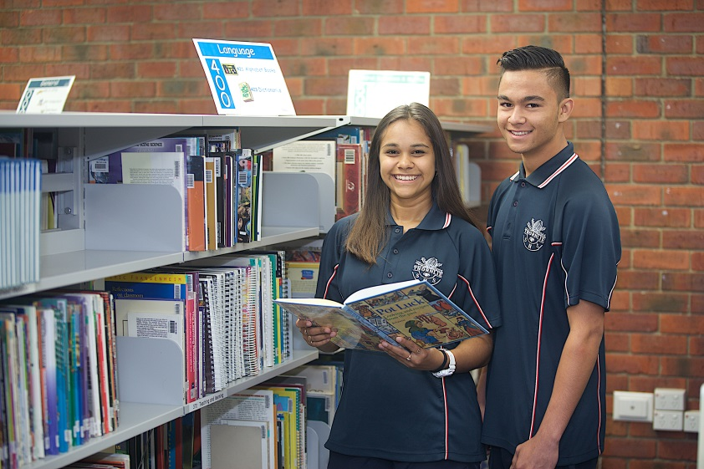

ENGLISH AS AN ADDITIONAL LANGUAGE (GEELD)
GENERAL SUBJECT

The EAL/D courses are designed for students who speak another language or dialect as their first or ‘home’ language. EAL/D focuses on development of the competent use of Standard Australian English (SAE) in a range of contexts. The EAL/D General course prepares students for a range of post-secondary destinations in further education, training and the workplace.

Enrolment into EAL/D as a Year 12 student cannot occur without eligibility approval. For a student to gain approval to enrol, the appropriate eligibility application must be completed and submitted to the Authority, along with the required supporting documentation. EAL/D eligibility status is determined on a case-by-case basis.

While eligibility for EAL/D is only required for students enrolling in Year 12 courses, schools are advised to collect documentation supporting EAL/D eligibility applications at the time of initial student enrolment in the school. Schools may submit students’ eligibility applications from the time that students are in Year 10 if they wish to determine the appropriate pathway for their students.

Any student who has not finalised their EAL/D eligibility by the time of the Year 12 enrolment deadline, as published in the WACE Activities Schedule for that year, will not be able to enrol in a Year 12 EAL/D course for that year.

For more information on this course, click the link below:

http://senior-secondary.scsa.wa.edu.au/syllabus-and-support-materials/english

ENGLISH AS AN ADDITIONAL LANGUAGE (AEELD)
ATAR SUBJECT

The EAL/D courses are designed for students who speak another language or dialect as their first or ‘home’ language. EAL/D focuses on development of the competent use of Standard Australian English (SAE) in a range of contexts. The EAL/D ATAR course develops academic English skills to prepare students for tertiary study.

Enrolment into EAL/D as a Year 12 student cannot occur without eligibility approval. For a student to gain approval to enrol, the appropriate eligibility application must be completed and submitted to the Authority, along with the required supporting documentation. EAL/D eligibility status is determined on a case-by-case basis.

While eligibility for EAL/D is only required for students enrolling in Year 12 courses, schools are advised to collect documentation supporting EAL/D eligibility applications at the time of initial student enrolment in the school. Schools may submit students’ eligibility applications from the time that students are in Year 10 if they wish to determine the appropriate pathway for their students.

Any student who has not finalised their EAL/D eligibility by the time of the Year 12 enrolment deadline, as published in the WACE Activities Schedule for that year, will not be able to enrol in a Year 12 EAL/D course for that year.

For more information on this course, click the link below:

http://senior-secondary.scsa.wa.edu.au/syllabus-and-support-materials/english

ENROLMENT CRITERIA FOR EAL/D AS A YEAR 12 STUDENT
If you do not speak Standard Australian English as your home language or are profoundly deaf and have had limited schooling in English or a limited period of residence in a country where English is not widely used, you may be eligible to enrol in EAL/D.

Eligibility criteria do not apply for this course in Year 11, but they do in Year 12.
There is a form that needs to be completed in Year 11 to ensure you are permitted to enrol in EAL/D in Year 12.
It is your responsibility to ensure the form is fully and accurately completed before it is submitted. The application form, stating the deadlines for submission, is available on the Authority website at www.scsa.wa.edu.au/internet/Events_and_Forms/Application_Order_Forms.You should discuss your enrolment options with your year coordinator.
Health & Physical Education

HEALTH STUDIES (GEHEA)
GENERAL SUBJECT

In this General course students explore health as a dynamic quality of life. They will consider the way in which beliefs and attitudes influence health decisions and learn how to plan and take action that will promote their own and the health of others. They examine the impact of social and environmental factors on health and use inquiry skills to investigate and respond to relevant issues. The course also provides students with opportunities to develop skills that will enable them to pursue careers in health promotion, research or community health care.

For more information on this course, click the link below:
http://senior-secondary.scsa.wa.edu.au/syllabus-and-support-materials/health-and-physical-education

HEALTH STUDIES (AEHEA)
ATAR SUBJECT

In this ATAR course students explore health as a dynamic quality of life. They examine the impact of social, environmental, economic and biomedical determinants on health and their collective contribution to health disparities, as well as exploring approaches to address barriers which prevent groups from experiencing better health. Students apply inquiry skills to examine and analyse health issues, develop arguments and draw evidence-based conclusions. The course also provides students with opportunities to develop skills that will enable them to pursue careers in health promotion, research or community health care.

* Students are required to purchase a textbook for this course, please check the booklist.

For more information on this course, click the link below:
http://senior-secondary.scsa.wa.edu.au/syllabus-and-support-materials/health-and-physical-education

OUTDOOR EDUCATION (GEOED)
GENERAL SUBJECT

Through interaction with the natural world, Outdoor Education aims to develop an understanding of our relationships with the environment, others and ourselves.

The Outdoor Education General course focuses on outdoor activities in a range of environments, including bushwalking, sailing, climbing and orienteering. It provides students with an opportunity to develop essential life skills and physical activity skills, and an opportunity to develop a comprehensive understanding of the environment and develop a positive relationship with nature.

The course also provides students with opportunities to develop skills that will enable them to pursue personal interests and careers in outdoor pursuits, environmental management, or eco-tourism.

Note:
- Prerequisite: Students must attend a pre-course swim evaluation session held during Term 1 2020.
- Students must attend and early start (period 0) class once a week and to attend after-hours expeditions totalling up to 6 nights. There will be some additional costs for these expeditions.
- Students are required to purchase a red “Thornlie SHS” Outdoor Education shirt. This shirt must be worn during practical sessions and can be purchased from the teacher for $30.
- As this is a high cost subject, full payment or payment plan must be organised for payment of camps and excursion costs. (This is above the course fee)

For more information on this course, click the link below:
http://senior-secondary.scsa.wa.edu.au/syllabus-and-support-materials/health-and-physical-education

PHYSICAL EDUCATION STUDIES (GEPES)
GENERAL SUBJECT

Physical Education Studies contributes to the development of students’ physical, social and emotional growth.

The Physical Education Studies General course provides students with opportunities to understand and improve performance through the integration of theoretical concepts and practical activities.

Through engagement as performers, leaders, coaches, analysts and planners of physical activity, students may develop skills that can be utilised in leisure, recreation, education, sport development, youth work, health and medical fields.

Note:
- Students may need to attend an early start (period 0) class once a week.
- Students are required to wear their full Physical Education uniform during practical sessions. Students can buy the new white upper school “Thornlie SHS” Physical Education shirt from the physical education office for $30.

For more information on this course, click the link below:
http://senior-secondary.scsa.wa.edu.au/syllabus-and-support-materials/health-and-physical-education

PHYSICAL EDUCATION STUDIES (RUGBY) (GEPESR)
GENERAL SUBJECT

The content and concepts of this course are similar to the above Physical Education Studies Unit, however Physical Education Studies Rugby is designed for students who have had successful experience in Special Rugby and is aimed at those achieving a B grade or better in Year 10. This course follows the curriculum of Physical Education General with a focus on the sport of Rugby.

This course involves both theoretical and practical components of the study of Physical Education and how it relates to the sport of Rugby. Students will spend two (2) periods per week in the classroom and two (2) periods per week participating in practical Rugby sessions.

In addition to the set course work students studying this unit will have the opportunity to participate in inter-school competitions in Rugby Union, Rugby League, Touch Rugby and Flag Football. Students will also have the opportunity to gain coaching, refereeing and first aid qualifications.

For more information on this course, click the link below:
http://senior-secondary.scsa.wa.edu.au/syllabus-and-support-materials/health-and-physical-education

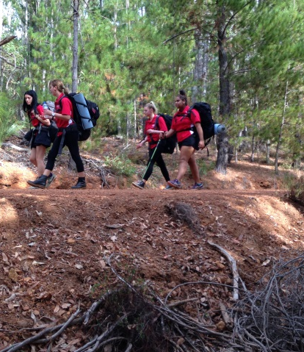
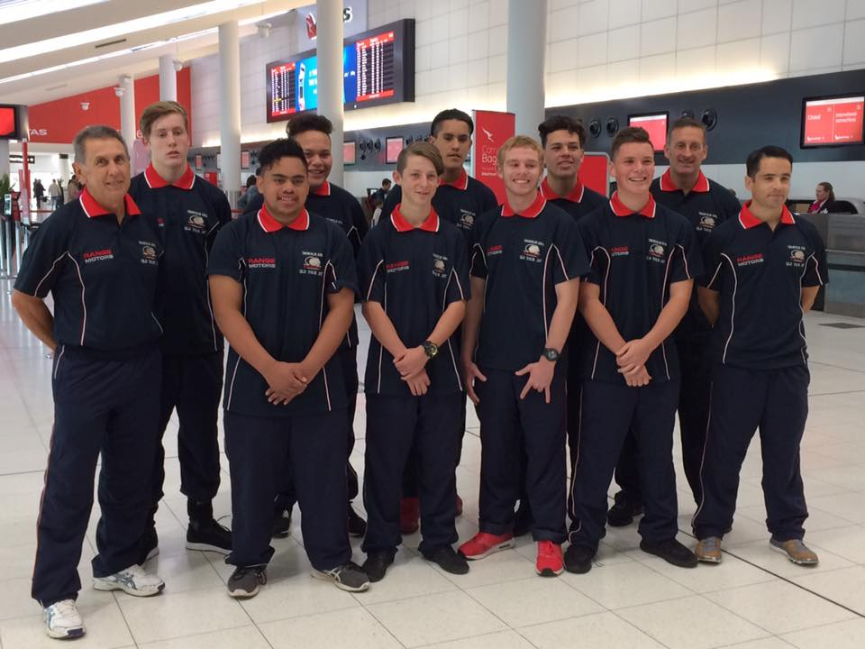
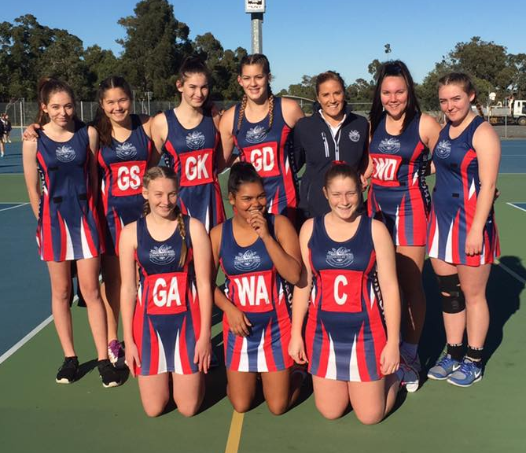
Humanities & Social Sciences

ANCIENT HISTORY (GEHIA)
GENERAL SUBJECT

The Ancient History General course enables students to study life in early civilisations, based on the interpretation of the physical and written remains of different ancient societies. The study of ancient civilisations illustrates the development of distinctive features of contemporary societies; for example, social organisation and religion.

The course also explores the possible motivations and actions of individuals, and how they shaped the political, social and cultural landscapes of the ancient world. Students are introduced to the process of reconstructing the past using often fragmentary evidence from a range of written and archaeological sources, and the skills associated with the analysis of historical sources.

The Year 11 syllabus is divided into two units and covers Ancient civilisations and cultures as well as Power in the ancient world.

For more information on this course, click the link below:
http://senior-secondary.scsa.wa.edu.au/syllabus-and-support-materials/humanities-and-social-sciences

BUSINESS MANAGEMENT & ENTERPRISE (AEBME)
ATAR SUBJECT

The Business Management & Enterprise ATAR course gives students the opportunity to understand how vital business is to individuals and society and how it impacts on many aspects of our lives.

The course aims to prepare all students for a future where they will need to identify possibilities and create opportunities within a business environment.

The course equips students to proactively participate in the dynamic world of business, behave responsibly and demonstrate integrity in business activities.

Designed for students entering university and studying business in its many forms, such as international relations, human resource management, advertising, marketing and public relations. Students will develop knowledge in all the above fields and understand concepts such as market mix, motivation of employees, investment, shares, GDP, interest rates, technological impacts, public image green businesses and much more.

For more information on this course, click the link below:
http://senior-secondary.scsa.wa.edu.au/syllabus-and-support-materials/humanities-and-social-sciences

CAREER & ENTERPRISE (GECAE)
GENERAL SUBJECT

Career education involves learning to manage and take responsibility for personal career development. The Career and Enterprise General course involves recognising one’s individual skills and talents, and using this understanding to assist in gaining and keeping work.

The course develops a range of work skills and an understanding of the nature of work. Key components of the course include: the development of an understanding of different personality types and their link to career choices; entrepreneurial behaviours; learning to learn; and the exploration of social, cultural and environmental issues that affect work, workplaces and careers.

For more information on this course, click the link below:

http://senior-secondary.scsa.wa.edu.au/syllabus-and-support-materials/humanities-and-social-sciences

PHILOSOPHY AND ETHICS (GEPAE)
GENERAL SUBJECT

Philosophical thought shapes what people think, what they value, what they consider to be true, and how they engage with others and the world around them. It is one of the foundations of all academic disciplines. It seeks to shed light on questions, such as: what is real; what and how do we understand; how should we live; what is it to be human; and who am I? It deals with issues and problems that cannot be addressed adequately by appealing to experience and experiment alone. Philosophical inquiry requires that we question our assumptions, beliefs, and our reasons for holding them. The Philosophy and Ethics General course aims to empower students to make independent judgements based on reason.
Doing philosophy is a practical activity. We do philosophy, for example, when we seek to define something, when we challenge assumptions, when we construct an argument, and when we think about what we are doing, how we are doing it and to what ends. The study of philosophy gives us a set of skills that better enables us to understand, evaluate and engage with our world, whether that is our personal or our social world, our world of work or the wider questions of how the world works. The relation between the disciplines of philosophy and ethics in this course requires some explanation. Traditionally, ethics has been regarded as a branch of philosophy, alongside metaphysics and epistemology, so that reference to philosophy will normally include reference to ethics. The title ‘Philosophy and Ethics’ gives ethics a prominent status, signifying that it has particular importance in this course. This status recognises that every member of a society faces ethical issues. A philosophical approach helps people to reflect on, and better understand, difficult ethical issues.
In philosophy and ethics, disagreement is common. Methods of inquiry and the skills of critical reasoning help us deal more effectively with disagreement. This course places considerable emphasis on students who contribute constructively to a philosophical Community of Inquiry. A philosophical Community of Inquiry, at its simplest, is a collaborative and cooperative process through which students learn with others, and from others, how to engage in philosophical discourse. Such discourse seeks to clarify, analyse, evaluate, and define concepts and issues to help students understand and deal with complex questions raised by popular culture, by contemporary events and by the history of ideas. A philosophical Community of Inquiry uses the skills of critical reasoning to help students deal more effectively and tolerantly with disagreement.
Employers are increasingly searching for people who can analyse new situations and devise and evaluate appropriate strategies to manage them. The Philosophy and Ethics General course develops thinking skills and moral discernment that students apply to a range of practical situations in their personal, social, and working lives. For more information on this course, click the link below:
http://senior-secondary.scsa.wa.edu.au/syllabus-and-support-materials/humanities-and-social-sciences

PSYCHOLOGY (AEPSY)
ATAR SUBJECT

Psychology is the scientific study of how people think, feel and act. It aims to answer important questions such as what factors influence human development. While there are other disciplines that overlap with psychology's main aim to understand humans, psychology is rigorous in its use of scientific method. This allows for systematic exploration into the complexities of human behavior based on evidence gathered through planned investigations.

This course introduces students to a breadth of knowledge focusing on the psychology of self and others. Psychological knowledge helps us understand factors relating to individuals, such as: cognition, or the way we think; biological bases of behavior; and personality, the enduring traits that distinguish individuals. Psychological knowledge also helps us understand the way that individuals function within groups. This consists of knowledge associated with socialization, moral development, the formation of attitudes and how people relate and communicate. On a larger scale, psychological knowledge can help us to understand how individuals function within different contexts and how this is influenced by culture, shaping people's values, attitudes and beliefs.

This course is designed to integrate the understanding of scientific principles, the acquisition of psychological knowledge and the application of both in an enjoyable and contemporary way. The study of psychology is highly relevant to further studies in the health professions; education, human resources, social sciences, sales, media and marketing and management.

For more information on this course, click the link below:

https://senior-secondary.scsa.wa.edu.au/syllabus-and-support-materials/science/psychology

PSYCHOLOGY (GEPSY)
GENERAL SUBJECT

Psychology is the scientific study of how people think, feel and act. It aims to answer important questions such as what factors influence human development. While there are other disciplines that overlap with psychology's main aim to understand humans, psychology is rigorous in its use of scientific method. This allows for systematic exploration into the complexities of human behavior based on evidence gathered through planned investigations.

This course introduces students to a breadth of knowledge focusing on the psychology of self and others. Psychological knowledge helps us understand factors relating to individuals, such as: cognition, or the way we think; biological bases of behavior; and personality, the enduring traits that distinguish individuals. Psychological knowledge also helps us understand the way that individuals function within groups. This consists of knowledge associated with socialization, moral development, the formation of attitudes and also how people relate and communicate. On a larger scale, psychological knowledge can help us to understand how individuals function within different contexts and how this is influenced by culture, shaping people's values, attitudes and beliefs.

This course is designed to integrate the understanding of scientific principles, the acquisition of psychological knowledge and the application of both in an enjoyable and contemporary way. The study of psychology is highly relevant to further studies in the health professions; education, human resources, social sciences, sales, media and marketing and management.

For more information on this course, click the link below:

https://senior-secondary.scsa.wa.edu.au/syllabus-and-support-materials/science/psychology

MODERN HISTORY (AEHIM)
ATAR SUBJECT

The Modern History ATAR course enables students to study the forces that have shaped today’s world and provides them with a broader and deeper comprehension of the world in which they live. While the focus is on the 20th century, the course refers back to formative changes from the late 18th century onwards and encourages students to make connections with the changing world of the 21st century.

Modern history enhances students’ curiosity and imagination and their appreciation of larger themes, individuals, movements, events and ideas that have shaped the contemporary world. The themes that run through the units include: local, national and global conflicts and their resolution; the rise of nationalism and its consequences; the decline of imperialism and the process of decolonisation; the continuing struggle for the recognition of human rights; the transformation of social and economic life; the regional shifts in power and the rise of Asia; and the changing nature and influence of ideologies.

For more information on this course, click the link below:
http://senior-secondary.scsa.wa.edu.au/syllabus-and-support-materials/humanities-and-social-sciences

Languages

JAPANESE: SECOND LANGUAGE (AEJSL)
ATAR SUBJECT

The Japanese: Second Language ATAR course is designed to further develop students’ knowledge and understanding of the culture and the language of Japanese-speaking communities, providing them with opportunities to gain a broader and deeper understanding of Japanese and extend and refine their communication skills.

The course focuses on the interrelationship of language and culture, and equips students with the skills needed to function in an increasingly globalised society, a culturally and linguistically diverse local community, and provides them with the foundation for life-long language learning. Relevant and engaging tasks, delivered through a range of appropriate contexts and topics, develop literacy in the Japanese language as well as extend literacy development in English.

Languages Bonus
Students who complete Units 3 and 4 of Japanese: Second Language (ATAR) are eligible for a Languages Bonus of 10% of their scaled Languages mark which will count towards their TEA.

For more information on this course, click the link below:
http://senior-secondary.scsa.wa.edu.au/syllabus-and-support-materials/languages

ENROLMENT CRITERIA FOR WACE LANGUAGE COURSES
If you wish to study a WACE language course (excluding Aboriginal Languages of Western Australia), there is a form that needs to be completed to ensure you are permitted to enrol in the selected course.

Enrolment criteria considerations include residency in the country where that language is spoken and exposure to that language either at a school or in the home. It is your responsibility to ensure that the form is completed fully and accurately before it is submitted. The application form, stating the deadlines for submission, is available on the Authority website at www.scsa.wa.edu.au/internet/Events_and_Forms/Application_Order_Forms.You should discuss your enrolment options with your careers counsellor.

Mathematics

MATHEMATICS FOUNDATION (FEMAT)
FOUNDATION SUBJECT

The Mathematics Foundation course focuses on building the capacity, confidence and disposition to use mathematics to meet the numeracy standard for the WACE. This course is for students who have not demonstrated the numeracy standard in the OLNA.

It provides students with the knowledge, skills and understanding to solve problems across a range of contexts including personal, community and workplace/employment. This course provides the opportunity for students to prepare for post-school options of employment and further training.

Note:
(a) If students reach the minimum standard (Category 3) in Round 1 (Semester 1), they will be required to change out of the Foundation course and into the General course for Semester 2.
(b) If students reach the minimum standard (Category 3) in Round 2 (Semester 2), they will not be required to change out of the Foundation course.

For more information on this course, click the link below:
http://senior-secondary.scsa.wa.edu.au/syllabus-and-support-materials/mathematics

MATHEMATICS ESSENTIAL (GEMAE)
GENERAL SUBJECT

The Mathematics Essential General course focuses on enabling students to use mathematics effectively, efficiently and critically to make informed decisions in their daily lives.

It provides students with the mathematical knowledge, skills and understanding to solve problems in real contexts for a range of workplace, personal, further learning and community settings. This course offers students the opportunity to prepare for post-school options of employment and further training.

Prerequisites:
- Students should have demonstrated an achievement of Category 2 or above in their OLNA Numeracy Assessment

For more information on this course, click the link below:
http://senior-secondary.scsa.wa.edu.au/syllabus-and-support-materials/mathematics

MATHEMATICS APPLICATIONS (AEMAA)
ATAR SUBJECT

This course focuses on the use of mathematics to solve problems in contexts that involve financial modelling, geometric and trigonometric analysis, graphical and network analysis, and growth and decay in sequences. It also provides opportunities for students to develop systematic strategies based on the statistical investigation process for answering statistical questions that involve analysing univariate and bivariate data, including time series data.

The Mathematics Applications ATAR course is designed for students who want to extend their mathematical skills beyond Year 10 level, but whose future studies or employment pathways do not require knowledge of calculus. The course is designed for students who have a wide range of educational and employment aspirations, including continuing their studies at university or TAFE.

Prerequisites:
- OLNA (Stage 3) and achievement of the following grades:
Pathway AE (55% in year 10),
Pathway 1 (70% and above in year 10) or

Note:
- Final Exams for this course will be held at the same time as the Year 12 Exams (During the Sept/Oct school holidays)

For more information on this course, click the link below:
http://senior-secondary.scsa.wa.edu.au/syllabus-and-support-materials/mathematics

MATHEMATICS METHODS (AEMAM)
ATAR SUBJECT

This course focuses on the use of calculus and statistical analysis. The study of calculus provides a basis for understanding rates of change in the physical world, and includes the use of functions, their derivatives and integrals, in modelling physical processes. The study of statistics develops students’ ability to describe and analyse phenomena that involve uncertainty and variation.

Mathematics Methods provides a foundation for further studies in disciplines in which mathematics and statistics have important roles. It is also advantageous for further studies in the health and social sciences. In summary, this course is designed for students whose future pathways may involve mathematics and statistics and their applications in a range of disciplines at the tertiary level.

Prerequisites:
- 70% and above in Year 10AE

Note:
- Final Exams for this course will be held at the same time as the Year 12 Exams (During the Sept/Oct school holidays)

For more information on this course, click the link below:
http://senior-secondary.scsa.wa.edu.au/syllabus-and-support-materials/mathematics

MATHEMATICS SPECIALIST (AEMAS)
ATAR SUBJECT

This course provides opportunities, beyond those presented in the Mathematics Methods ATAR course, to develop rigorous mathematical arguments and proofs, and to use mathematical models more extensively. Mathematics Specialist contains topics in functions and calculus that build on and deepen the ideas presented in the Mathematics Methods course, as well as demonstrate their application in many areas.

The Mathematics Specialist course also extends understanding and knowledge of statistics and introduces the topics of vectors, complex numbers and matrices. Mathematics Specialist is the only ATAR mathematics course that should not be taken as a stand-alone course and it is recommended to be studied in conjunction with the Mathematics Methods ATAR course as preparation for entry to specialised university courses such as engineering, physical sciences and mathematics.

Prerequisites:
- 75% and above in Year 10AE

Note:
- Final Exams for this course will be held at the same time as the Year 12 Exams (During the Sept/Oct school holidays)

For more information on this course, click the link below:
http://senior-secondary.scsa.wa.edu.au/syllabus-and-support-materials/mathematics
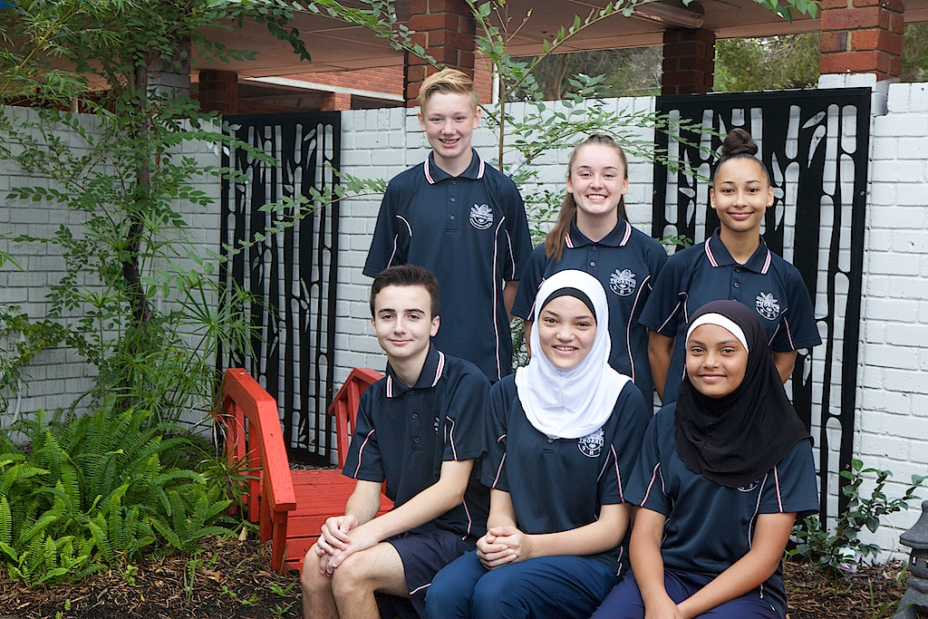

Science

CHEMISTRY (AECHE)
ATAR SUBJECT

The Chemistry ATAR course equips students with the knowledge, understanding and opportunity to investigate properties and reactions of materials. Theories and models are used to describe, explain and make predictions about chemical systems, structures and properties. Students recognise hazards and make informed, balanced decisions about chemical use and sustainable resource management. Investigations and laboratory activities develop an appreciation of the need for precision, critical analysis and informed decision making.

This course prepares students to be responsible and efficient users of specialised chemical products and processes at home or in the workplace. It also enables students to relate chemistry to other sciences, including biology, geology, medicine, molecular biology and agriculture, and prepares them for further study in the sciences.

For more information on this course, click the link below:
http://senior-secondary.scsa.wa.edu.au/syllabus-and-support-materials/science

HUMAN BIOLOGY (AEHBY)
ATAR SUBJECT

The Human Biology ATAR course gives students a chance to explore what it is to be human—how the human body works, the origins of human variation, inheritance in humans, the evolution of the human species and population genetics. Through their investigations, students research new discoveries that increase our understanding of human dysfunction, treatments and preventative measures.

Practical tasks are an integral part of this course and develop a range of laboratory skills; for example, biotechnology techniques. Students learn to evaluate risks and benefits to make informed decisions about lifestyle and health topics, such as diet, alternative medical treatments, use of chemical substances and the manipulation of fertility.

For more information on this course, click the link below:
http://senior-secondary.scsa.wa.edu.au/syllabus-and-support-materials/science

INTEGRATED SCIENCE (GEISC)
GENERAL SUBJECT

The Integrated Science General course enables students to investigate science issues in the context of the world around them. It encourages students to develop their scientific skills of curiosity, observation, collection and analysis of evidence, in a range of contexts.

The multidisciplinary approach, including aspects of biology, chemistry, geology and physics, further encourages students to be curious about the world around them and assume a balanced view of the benefits and challenges presented by science and technology. Students conduct practical investigations that encourage them to apply what they have learnt in class to real-world situations and systems.

For more information on this course, click the link below:
http://senior-secondary.scsa.wa.edu.au/syllabus-and-support-materials/science

PHYSICS (AEPHY)
ATAR SUBJECT

In the Physics ATAR course students will learn how energy and energy transformations can shape the environment from the small scale, in quantum leaps inside an atom’s electron cloud, through the human scale, in vehicles and the human body, to the large scale, in interactions between galaxies.

Students have opportunities to develop their investigative skills and use analytical thinking to explain and predict physical phenomena. Students plan and conduct investigations to answer a range of questions, collect and interpret data and observations, and communicate their findings in an appropriate format. Problem-solving and using evidence to make and justify conclusions are transferable skills that are developed in this course.

For more information on this course, click the link below:
http://senior-secondary.scsa.wa.edu.au/syllabus-and-support-materials/science

HUMAN BIOLOGY (GEHBY)
GENERAL SUBJECT

The Human Biology General course gives students a chance to explore how the human body works. In year 11, students investigate various body systems including the respiratory, digestive, cardiovascular, and excretory systems. They look at the roles diet and nutrition play in health and research contemporary treatments for dysfunctions of these systems. Students supplement their learning through real or virtual dissections and practical examination of cells, organs, and systems.

In year 12 the focus is on bones, muscles, nerves, and hormones, and how they maintain the body to act in a coordinated manner. The causes and spread of disease and how humans respond to invading pathogens are studied, as well as the role of males and females in the process of reproduction.

For more information on this course, click the link below:
http://senior-secondary.scsa.wa.edu.au/syllabus-and-support-materials/science

Technologies

APPLIED INFORMATION TECHNOLOGY (GEAIT)
GENERAL SUBJECT

Throughout the Applied Information Technology General course, students investigate client-driven issues and challenges, devise solutions, produce models or prototypes and then evaluate and refine the design solution in collaboration with the client.

Students are provided with the opportunity to experience, albeit in a school environment, developing digital solutions for real situations.

Students will use industry standard software such as Adobe Photoshop, Director, Flash, dreamweaver, the MS Office Suite and premier as well as online environments such as wix and soundnation.

The course provides a sound theoretical and practical foundation, offering pathways to further studies and a wide range of technology based careers.

For more information on this course, click the link below:
http://senior-secondary.scsa.wa.edu.au/syllabus-and-support-materials/technologies

COMPUTER SCIENCE (AECSC)
ATAR SUBJECT

This course is designed to develop students understanding of the creation of computer systems, databases and programs that affect our lives every day. Students will gain knowledge of the underlying principles of information systems, system design and
development, database design and development and programming.

Designed for students heading towards university entrance into fields of computing, software development, information systems, system analysis etc.

Students develop problem-solving abilities and technical skills as they learn how to diagnose and solve problems in the course of understanding the building block of computing

For more information on this course, click the link below:
http://senior-secondary.scsa.wa.edu.au/syllabus-and-support-materials/technologies

DESIGN (TECHNICAL GRAPHICS) (GEDEST)
GENERAL SUBJECT

In the Design course students develop skills and processes for current and future industry and employment markets. Students are equipped with the knowledge and skills to understand design principles and processes, analyse problems and possibilities, and devise innovative strategies within design contexts. These include photography, graphics, dimensional design and technical graphics. The Design course also emphasises the scope of design in professional industries allowing students to maximise university pathways.

Design can be offered by schools in several different contexts. This course specifically studies Technical Graphics.
This context may include elements of freehand sketching and presentation techniques to include rendering skills, tone and line work; CAD and instrument drawing skills; 2D/3D introduction, study tools and equipment, drawing layout, conventions, orthographic projection, perspective drawing and engineering drawing.

Technical Graphics uses conventions of technical drawing and computer-aided design to create designs that deal with mainly three dimensional subjects, usually of an industrial nature.

For more information on this course, click the link below:
http://senior-secondary.scsa.wa.edu.au/syllabus-and-support-materials/arts

FOOD SCIENCE AND TECHNOLOGY (GEFST)
GENERAL SUBJECT

The Food Science and Technology General course provides opportunities for students to explore and develop food-related interests and skills. Food impacts on every aspect of daily life and is essential for maintaining overall health and wellbeing.

Students organise, implement and manage production processes in a range of food environments and understand systems that regulate food availability, safety and quality. Knowledge of the sensory, physical, chemical and functional properties of food is applied in practical situations.

Students investigate the food supply chain and value-adding techniques applied to food to meet consumer and producer requirements. Principles of dietary planning, adapting recipes, and processing techniques, are considered for specific nutritional needs of demographic groups. Occupational safety and health requirements, safe food handling practices, and a variety of processing techniques, are implemented to produce safe, quality food products. This course may enhance employability and career opportunities in areas that include nutrition, health, food and beverage manufacturing, food processing, community services, hospitality and retail.

This course has a high practical food content.
Students will learn how to operate a commercial coffee machine. They will be rostered on throughout the year to prepare and serve coffee and food to clients of the Thornlie Senior High School Flourish Café during recess.

Students will be required to attend either a period 0 or period 6 for practical lessons; this will be determined by the timetable. Additionally all students will be required to participate in the operation of Flourish Cafe.

For more information on this course, click the link below:
http://senior-secondary.scsa.wa.edu.au/syllabus-and-support-materials/technologies

MATERIALS, DESIGN & TECHNOLOGY METALS (GEMDTM) GENERAL SUBJECT

The Materials Design and Technology (Metals) General course is a practical course. Working with metals, students develop a range of manipulation, processing, manufacturing and organisational skills.

When designing with metals, they develop cognitive skills, such as solving problems, generating ideas, creative design strategies and communicating what they do. This makes them more technologically literate and, as consumers, enables them to make more informed decisions about the use and misuse of technology.

The Materials Design and Technology (Metals) General course aims to prepare all students for a future in a technological and material world by providing the foundation for lifelong learning about how products are designed and how materials are developed and used.

For more information on this course, click the link below:
http://senior-secondary.scsa.wa.edu.au/syllabus-and-support-materials/technologies

MATERIALS, DESIGN & TECHNOLOGY WOOD (GEMDTW) GENERAL SUBJECT

The Materials Design and Technology (Wood) General course is a practical course. Working with wood, students develop a range of manipulation, processing, manufacturing and organisational skills.

When designing with wood, they develop cognitive skills, such as solving problems, generating ideas, creative design strategies and communicating what they do. Students are provided with a foundation for lifelong learning and wood product design and manufacture.

The Materials Design and Technology (Wood) General course is separate to the Certificate II in Visual Arts (Wood) and would suit students who would like to continue their interest in woodwork skills but wish to pursue another Certificate course.

For more information on this course, click the link below:
http://senior-secondary.scsa.wa.edu.au/syllabus-and-support-materials/technologies

Ovens Road, THORNLIE WA 6108
T 08 9376 2100 E thornlie.shs@education.wa.edu.au
www.thornlieshs.wa.edu.au

