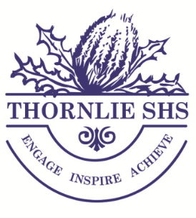
Year 8 Subject Selection Sheet 2022

Student Name: ___________________________________

In 2022, all Year 8 students will be enrolled in a common core of subjects - Mathematics, English, Science, Humanities & Social Science, Health & Physical Education, Languages and The Arts. The curriculum is designed to give students an opportunity to experience several different subjects but also allows for a level of personalisation.

In order to complete their subject selections students will be asked to choose a Technologies context (Home Economics or Design & Technology), as well as applying for a course of Health & Physical Education specialisation (PE or Netball or Rugby).
Students will do a semester each of both Performing and Visual Arts. Instrumental Music is an Arts subject and therefore a student can only do Music or Performing/ Visual Arts. Students will also be enrolled in either Japanese or Auslan/ Literacy Enrichment based upon the progress of their Literacy skills.

Students who have nominated for placement into courses such as Academic Excellence, Instrumental Music, Specialised Rugby and/or Netball Program, will receive a letter acknowledging their acceptance into these courses.

Compulsory Subjects
Subject | Cost | Subject | Cost
Mathematics (8MA) | $25.00 | Science (8SC) | $28.00
English (8EN) | $20.00 | Humanities & Social Science (8HASS) | $27.00
Health Education (8HE) | $10.00 | Digital Technologies (8TEC) | $10.00
Language/ Literacy | $10.00
The Arts, Including both  - Visual Arts (8VA) and 󠄀  - Performing Arts (8PA) or  Instrumental Music (8IM)^ | $60.00  $60.00* | Health & Physical Education  - Physical Education (8PE) or  - Netball Program (8NET)^ or  - Specialised Rugby (8RDP)^ | $15.00  $90.00*  $100.00*
Elective Subjects (tick one)

Home Economics (8HEC) | $30.00 | Design & Technology (8DT) | $30.00

Compulsory Subject Costs (Maths, English, Science, HASS, Health & PE, Language) | $205.00
Elective Subject Costs | $
Total Subject Costs  Office use:  High Cost Elective Subtotal | $
NOTE: (i) A minimum of 50% of the Total Subjects Costs is required with this application. (ii) For the student to be enrolled in their selected subjects, any elective subject costing more than $70.00 must be paid in full when paying the 50% minimum of the total subject costs. (iii) If the balance is not paid prior to the commencement of the school year, the student may be moved into a low cost elective class.

Parent Signature: __________________________________

Office Use Only

Receipt No: __________ Amount Paid: _________ Signature: ____________Date: _______________

