COMMUNITY SPIRIT

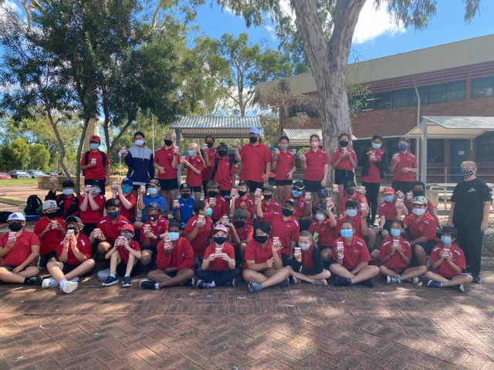

Thornlie Senior High School welcomes the Year 6 students and staff. They will be staying with us for the next 3 weeks whilst the Yale site is cleared after the recent fire.

To support Yale Primary School following the recent fire damage, last weekend Campion Education staff packed 48 boxes of supplies, and our Incident Support team filled and delivered 338 pencil cases for Years 1 to 6, Kindergarten and Pre-Primary supplies, 17 classroom teachers packs as well as stationery for admin, and workbooks and scrapbooks. Our Education security team picked up the supplies and delivered them on the Monday morning to the 3 schools who are hosting Yale staff and students. Staff at Statewide Services provided care cups and arranged morning tea (generously donated by Woolworths and Brumby’s) and have delivered additional resources requested by the teachers. Thank you to Brownes Dairy who donated chocolate milk to the Thornlie Senior High School Canteen for distribution to the Year 6 students who are attending.

What an incredible effort by all involved.  A big shout out to the staff and students from Yale Primary School who have been affected, and to everyone at South Thornlie Primary School, Thornlie Primary School and Thornlie Senior High School who are hosting them while the school remains closed.

South Thornlie Primary School Years K-4

Thornlie Primary School Year 5

Thornlie Senior High School Year 6