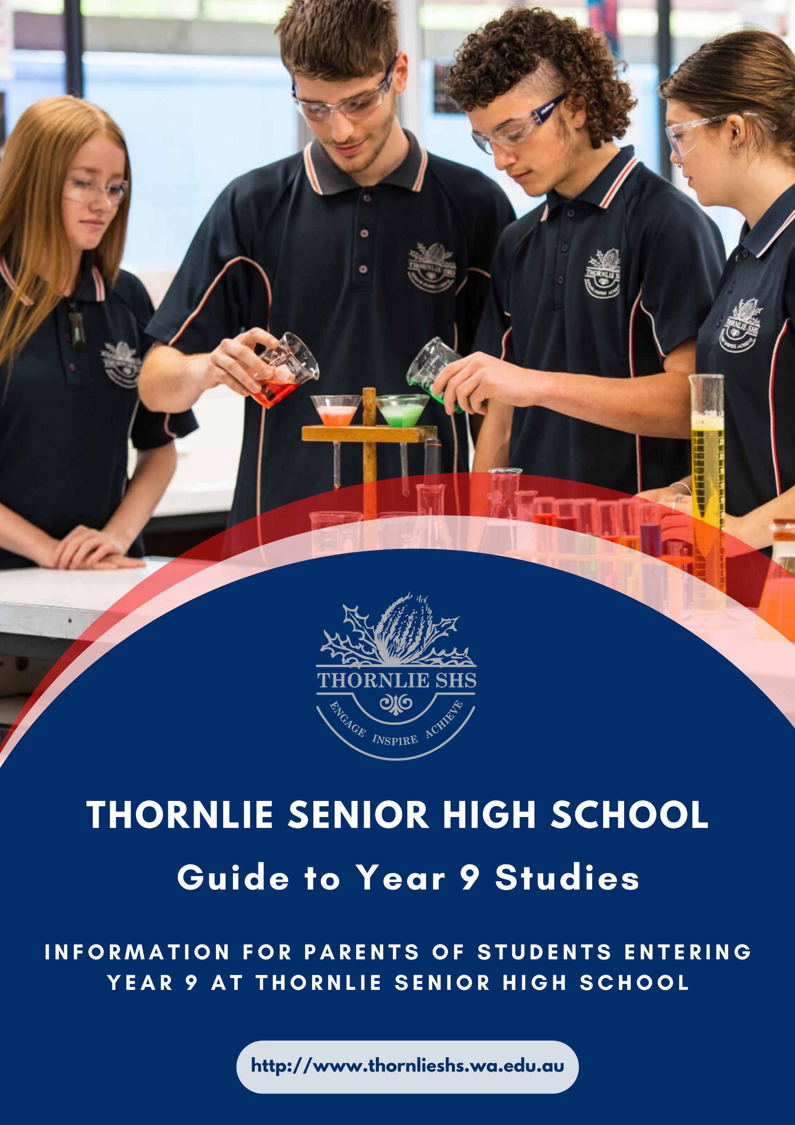

INTRODUCTION

The curriculum at Thornlie Senior High School for students in Year 9 is designed to specifically serve the needs of young adolescents. It is the aim of Thornlie Senior High School that every student has the opportunity to succeed academically so that when they exit secondary school they are literate, numerate, and educated/trained sufficiently well to enable them to take their place in our society as responsible and productive citizens. Thornlie Senior High School strives to foster a caring educational environment based on cooperation, self-responsibility and mutual respect while endeavouring to engage and stimulate students in an ever changing world.
This booklet serves to provide parents and students with the necessary information about the curriculum offerings in Year 9 and to assist students and parents in making informed subject selections for 2024.
Parents and students are encouraged to work together to select appropriate courses for 2024. Should you have any questions regarding course selection please contact the school on 6235 7900 during school office hours (8:00 am – 4:00 pm).

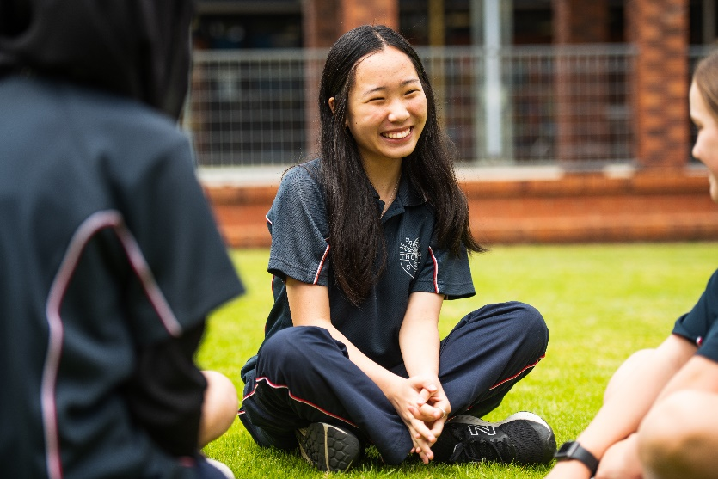
YEAR 9 COURSE SELECTION FOR 2024

Contents

Curriculum Requirements for Year 9 4

The Arts: 5

English: 6

Health & Physical Education: 7

Humanities & Social Sciences: 9

Languages: 11

Mathematics: 12

Science: 13

Technologies: 14

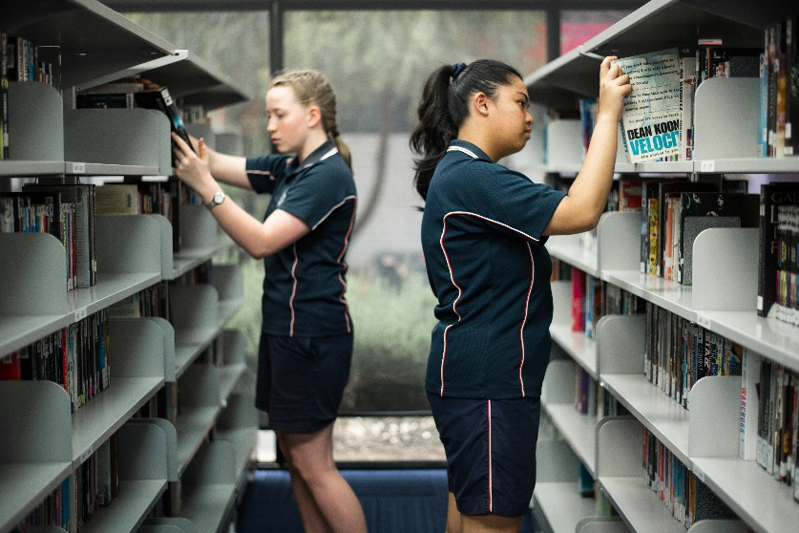

CURRICULUM REQUIREMENTS

Listed below are the course requirements for Year 9 students in 2024. The curriculum is designed to give students an opportunity to experience subjects from the eight (8) different learning areas. From the following table it can be seen that 19 periods are taken up with compulsory subjects. Students need to select 3 more subjects to ensure they are studying a total of 25 periods per week for each semester.

Compulsory Subjects | No. of periods per week for the year
English | 4
Mathematics | 4
Science | 4
Humanities and Social Sciences | 4
Physical Education | 2
Health Education | 1
3 electives must be chosen with a maximum of two from any one learning area
The Arts | NOTE:  Only one specialised elective may be chosen
Languages
Specialised Physical Education
Science - STEM
Technologies
TOTAL ELECTIVE PERIODS PER WEEK | 6
TOTAL PERIODS PER FOR THE YEAR | 25

Note:
It is not guaranteed that students will be able to be enrolled in all of their requested subjects due to resource and timetable constraints.
If a student selects a high cost elective their enrolment in the subject is only guaranteed when their school fees are paid in full.
Failure to pay will result in the student being withdrawn from the subject or being unable to participate fully in the subject.
Please complete the student choice selections thoughtfully as the ranked list for each learning area will assist in placing students in the next available subject.

Specialised and Scholarship Programs
Thornlie Senior High School offers the following Specialist and Scholarship programs:
- Specialist Rugby
- Academic Excellence
- Instrumental Music
- Netball

Students indicated their interest in one or more of these programs on entering Year 7 and participated in testing, auditions and trials to be considered. Students participating in these programs are invited to continue with the program, if achieving satisfactory progress, through to the completion of Year 10. Other students performing well outside the program may be offered an Academic Excellence position in English, Mathematics, Science and Humanities and/or Social Sciences.
THE ARTS
The Arts The Arts
In the Arts Learning Area, students develop creative skills, critical appreciation and knowledge of artistic techniques and technologies in Dance, Graphic Design, Media, Music, Visual Arts and combinations of art forms. The Arts develop the student’s sense of personal and cultural identity and equips them for lifelong involvement in, and the appreciation of, the Arts.

DANCE - 9DAN
In Year 9 Dance, students will investigate the evolution of, and refine their technical competence in, specific dance genres including Jazz, Tap, Ballet, Lyrical, Contemporary, Pom, Cultural Dance and elements of Cheerleading and Acrobatics. Students will be required to present practical classwork to an audience in a professional performance, focusing on retention and clarity of movement, projection, focus, expression and musicality. Students will be given opportunities to choreograph using the elements of dance, choreographic devices and structures to develop their choreographic intent. Safe dance practices underlie all experiences as students perform within their own body capabilities and work safely in groups.

GRAPHIC DESIGN - 9GD
In this course, students are introduced to a range of basic design processes and practices as well as design materials and technologies. Students learn to develop visual ideas and concepts, using design skills/technology, Adobe Photoshop and Illustrator. During the course, students will obtain knowledge in the elements and principles of design which will result in designing in a range of industries that can include the advertising sector, logo design, posters, packaging and character design.

MEDIA - 9MED
The Arts Learning Area offers Year 9 students a unique program in Media. Students accepted into this course will use the latest technologies as they create and complete tasks in the areas of film, print media, animation and popular culture. Students will develop media skills and techniques as they work independently and in teams, creating projects in the fields of short feature films; replica Tik Tok or Instagram featurettes, stop-motion animation, advertising and photography. Projects specific to actual industry-based tasks. They will develop their knowledge using the Adobe CC Suite, such as Adobe Photoshop, Illustrator, Lightroom and Premiere Rush, as well as apps particular to media industries. By participating in the media course students will also develop the skills of self-discipline, self-reliance, and team spirit, creativity and confidence in their ability that are required for further studies in media.
VISUAL ARTS - 9VA
In Year 9, students will continue to develop their visual language, art knowledge, skills and techniques in the design and production of their artworks. They will have the opportunity to experience, adapt and manipulate materials, techniques, art styles/processes when producing 2D and/or 3D artworks. They will be encouraged to display and discuss their artworks with consideration to personal expression and audience. Students will extend their knowledge and use safe visual arts practice.

Students will develop a growing awareness of how and why artists, craftspeople and/or designers are influenced by other artists, their environment and the contexts of culture, time and place as they continue to apply knowledge of techniques, in the production of their own work.

Students are required to critically analyse traditional and contemporary artworks using various analysis frameworks, incorporating appropriate visual language, art terminology and conventions.

INSTRUMENTAL MUSIC - 9IM
This course continues the specialised music program for all scholarship music students who are learning an instrument or voice through the Instrumental Music School Services (IMSS) program. The course is designed to provide intensive training in music through the areas of Aural, Theory, Arranging & Composing, Performing and History of Music.

Students in this program will receive free weekly instrumental or voice lessons from specialist teachers from the IMSS and will also be expected to participate in a large group ensemble – Guitar Ensemble (Junior or Senior), Choir or Concert Band to enhance their learning experience and generate opportunities to perform at both music concerts and festivals throughout the year. All students who participated in Year 8 instrumental music are expected to continue their music studies in this subject in Year 9 in order to continue to receive their free instrumental tuition.

ENGLISH
English English

In the English Learning Area, students learn about the English language - how it works and how to use it effectively. They develop an understanding of the way in which language operates as a social process and how to use language in a variety of forms and situations. They learn to speak, listen, view, read and write effectively.

English is a compulsory course and all students will study English for four (4) periods per week for the year.

English courses at Thornlie Senior High School are designed using the Australian Curriculum. These courses are also designed to facilitate a smooth transition into upper school courses.

English - 9EN
The English curriculum is built around the three interrelated strands of language, literature and literacy. Teaching and learning programs should balance and integrate all three strands. Together, the strands focus on developing students' knowledge, understanding and skills in listening, reading, viewing, speaking, writing and creating. Learning in English builds on concepts, skills and processes developed in earlier years, and teachers will revisit and strengthen these as needed.

In Years 9 and 10, students interact with peers, teachers, individuals, groups and community members in a range of face-to-face and online/virtual environments. They experience learning in familiar and unfamiliar contexts, including local community, vocational and global contexts.

Literacy Enrichment – 9LE
Literacy is a main focus at Thornlie SHS and this elective is offered to assist identified students with improving their literacy skills. The elective runs for two periods per week and the activities are tailored to students’ individual needs. Students study familiar text types in a way that strengthens their reading, comprehension, grammar and writing skills. Intensive NAPLAN preparation will assist them in meeting the benchmarks by the end of their schooling. Classes will be small, creating an advantage for the learner. Parents/guardians will be notified if their child is selected for this elective.
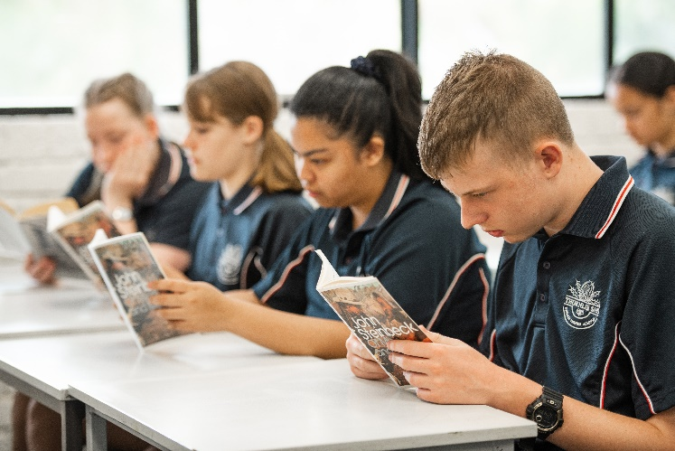
HEALTH AND PHYSICAL EDUCATION
Health & Physical Education Health & Physical Education

Health and Physical Education is a compulsory course. All students will study Health Education for one (1) period per week, and two (2) periods of Physical Education General. Students may also select one of the specialised electives for two (2) periods a week if desired.

In Year 9, the content provides for students to broaden their knowledge of the factors that shape their personal identity and the health and wellbeing of others. They further develop their ability to make informed decisions, taking into consideration the influence of external factors on their behaviour and their capacity to achieve a healthy lifestyle. They continue to develop knowledge, skills, and understandings in relation to respectful relationships. With a focus on relationship skills that promote positive interactions and manage conflict.

Students focus on elements of speed and accuracy in different movement environments, while continuing to develop the efficiency of specialised movement skills. They explore ways to evaluate their own and others’ performances through analysis of skills and movement patterns using basic biomechanical concepts. Students transfer previous knowledge of outcomes in movement situations to inform and refine skills, strategies and tactics to maximise success.

Opportunities are provided for students to refine and consolidate skills and strategies for effective leadership and teamwork, and consistently apply ethical behaviour across a range of contexts.

The Health and Physical Education curriculum provides opportunities for students to develop, enhance and exhibit attitudes and values that promote a healthy lifestyle.

Physical Education Uniforms: Parents need to be aware that all students must change for all Physical Education classes. Students are required to wear a plain royal blue shirt, plain black shorts or track suit and sports shoes. Thornlie SHS PE shirts and shorts are available for purchase through the uniform shop.

COMPULSORY HEALTH & PHYSICAL EDUCATION SUBJECTS

HEALTH EDUCATION - 9HE
Students identify skills and strategies to manage change and promote all aspects of their own and others’ health, including making informed decisions, using assertive responses, and making contingency plans to avoid and prevent risks to health.

Students identify the impact of negative behaviours on relationships and describe a range of factors and their impact on a person’s emotional response and behaviour.

Topics include
Semester 1: Nutrition, Contraception and STI’s
Semester 2: Mental Health, Drugs & Alcohol, Drugs & Resilience and First Aid

PHYSICAL EDUCATION GENERAL - 9PE
Students perform a variety of individual movement skills and sequences demonstrating improved control, accuracy and efficiency in their performance. In competitive contexts, they implement a variety of tactics to achieve and intended outcome.

Students provide simple descriptions of how to measure physical responses to changes in movement. They action and understand linear, angular and general motion when reflecting on ways to improve performance outcomes. When faced with movement challenges, they select and implement simple tactical responses to achieve an intended outcome.

Sports include
Semester 1: Tennis, Cricket, Netball and Hockey.
Semester 2: Athletics, AFL, Volleyball and Sofcrosse.

SPECIALISED PHYSICAL EDUCATION ELECTIVES

All of the following Specialised Physical Education electives are high cost due to bus use, hire of venues, hire of outside instructors and the use of specialised equipment. The elective charges are compulsory.

For the student to be enrolled in their selected electives, any elective costing more than $70.00 must be paid in full when paying the 50% minimum of the total subject costs. If the balance is not paid prior to the commencement of the school year, the student may be moved into a low-cost elective class.

NETBALL - 9NET
Prerequisites: Students must be a competent netball player and have an interest and desire to improve their skills. Students are expected to participate in all classes and any associated training or match activities.

This year long course continues to develop the fundamental skills of Netball. The course will focus on individual netball technique and teamwork. From this course, students will be selected to represent Thornlie Senior High School at interschool tournaments and matches. Students will have the opportunity to undertake a Netball Australia accredited umpire course and have the benefit of occasional guest coaches from Netball WA.

At external venues students must wear the “Thornlie SHS” P.E. shirt. It is compulsory for all students to purchase a TSHS Netball dress. The cost is $100 and can be purchased from the school.

PHYSICAL RECREATION - 9PR
This course provides students the opportunity to achieve the H + PE outcomes in a non-competitive environment. It is designed to give students experiences in a variety of recreational pursuits at school. These may include: Archery, Table Tennis, Archery, Trampolining, Weights & Fitness, Indoor Soccer, and Bike Riding.

Places in this course are limited. This subject is aimed at students who enjoy playing sports and participating in recreational activities. During the year students will cover a variety of different types of sports/ activities which may not necessarily be covered in the Physical Education general course.

It is expected that students choosing this subject will already possess reasonable sporting skills and enthusiasm for physical activities.

SPECIALISED RUGBY - 9RDP
This course is designed as a continuation of the Year 8 Specialist Rugby Development Program and provides a progression into higher level skill development and knowledge in Rugby Union, Rugby League, Touch and League Tag for Year 9 players.

Students will continue to receive expert tuition from Thornlie SHS Rugby Academy staff, RugbyWA and NRL Junior Development Officers, guest coaches and speakers. Our aim is to continue to develop each student's individual skills, physical fitness, game abilities, and knowledge, so that they may reach their full potential in their chosen code. Within this program we will continue to place an emphasis on personal goal setting, values and leadership skills. Individuals will also be given an opportunity to learn and apply the different officiating skills at matches and carnivals. Students will once again have the chance to gain selection into one of our school representative teams and then compete in one or more of the Union, League, Touch and League-Tag inter-school competitions and carnivals held throughout the year.
Health & Physical Education Health & Physical Education

Selection Criteria
Successful applicants will need to meet one or more of the criteria listed below.

- Successful completion of the Year 8 Specialist Rugby Course with a final assessment grade of C or higher.
- Hold a current Rugby Scholarship or Traineeship at Thornlie SHS, having displayed a high standard of performance and behaviour in the Year 8 program.
- Be offered a Talent Identification Scholarship having attended both a specific skills assessment and an interview with School and Academy Co-ordinators.
- Be offered general entry into the program having displayed a keen interest in and suitable physical skills for Rugby Union and Rugby League. This type of entry is only possible should a vacancy exist in the class.

HUMANITIES & SOCIAL SCIENCES
Humanities & Social Sciences Humanities & Social Sciences

The Humanities and Social Sciences Learning Area develops students’ understanding of how individuals and groups live together and interact with their environment. Students develop a respect for cultural heritage and a commitment to social justice, the democratic process and ecological sustainability.

Humanities & Social Sciences is compulsory for all students in Year 9. Students will study HASS for four (4) periods per week for the year.

Humanities & Social Sciences aims to provide students with the skills, understandings and values to be effective citizens in Australian society.

HUMANITIES & SOCIAL SCIENCES - 9HASS
In Year 9, Humanities and Social Sciences consists of Civics and Citizenship, Economics and Business, Geography and History. Students develop increasing independence in critical thinking and skill application, which includes questioning, researching, analysing, evaluating, communicating and reflecting. They apply these skills to investigate events, developments, issues and phenomena, both historical and contemporary.

- Civics and Citizenship
Students continue to build on their understanding of the concepts of the Westminster system, democracy, democratic values, justice and participation. They examine the role of key players in the political system, the way citizens' decisions are shaped during an election campaign and how a government is formed. Students investigate how Australia's court system works in support of a democratic and just society.

- Economics and Business
Students are introduced to the concepts of specialisation and trade while continuing to further their understanding of the key concepts of scarcity, making choices, interdependence, and allocation and markets. They examine the connections between consumers, businesses and government, both within Australia and with other countries, through the flow of goods, services and resources in a global economy. The roles and responsibilities of the participants in the changing Australian and global workplace are explored.

- Geography
The concepts of place, space, environment, interconnection, sustainability and change continue to be developed as a way of thinking, which provides students with an opportunity to inquire into the production of food and fibre, the role of the biotic environment and to explore how people, through their choices and actions, are connected to places in a variety of ways. Students apply this understanding to a wide range of places and environments at the full range of scales, from local to global, and in a range of locations.

Biomes and food security are the main focus of study in this unit. Students examine the role of the environment and its role in food and fibre production and the challenges that result from expanding production in the future. Students will also examine the connections between people and places and the effects of transport and information technologies.

- History
Students develop their historical understanding through key concepts, including evidence, continuity and change, cause and effect, perspectives, empathy, significance and contestability. These concepts are investigated within the historical context of the making of the modern world from 1750 to 1918. It was a period of industrialisation and rapid change in the ways people lived, worked and thought. It was also a period of nationalism, imperialism and the colonisation of Australia They consider how new ideas and technological developments contributed to change in this period, and the significance of World War I.

LANGUAGES

In the Languages Learning Area, students learn to communicate effectively in languages other than English. They gain an understanding of other societies, the ability to interact with people and cultures other than their own and practical skills which they can use in future social, cultural and vocational areas. Through Languages, students are also able to further develop their skills and understanding in English and of literacy in general.

Languages are an integral part of a balanced academic course of study. All students with an aptitude and interest in languages are strongly encouraged to continue their studies into Year 9 and beyond.

JAPANESE - 9JSL
An additional language is a valuable asset in a rapidly globalising Australia. Being able to communicate with people around the world gives students the chance to learn more about their own lives, as well as the lives of others.

Japan is one of Australia’s closest friends in our Asia-Pacific neighbourhood. Japan remains our second closes trading partner, and Japanese-speaking Australians are highly-valued employees all over the world.

Japan and Australia participate in close cultural exchange. From dance to painting, music to sport, learning more about Japanese language and culture will open students’ eyes to a history and people that are constantly changing, and always fascinating.
In Year 9, students will build on the skills they acquired in Year 8 and explore the culture and language of Japan through the topics of school life, family and holidays.

PLEASE NOTE THAT ENROLMENT IN YEAR 9 JAPANESE REQUIRES COMPLETION OF YEAR 8 JAPANESE.
Languages Languages

MATHEMATICS

In Mathematics, students will learn to use ideas about number, space, measurement and chance. Students will use mathematical ways of representing patterns and relationships, to describe, interpret and reason about their social and physical world. Mathematics plays a key role in the development of students’ numeracy and assists learning across the curriculum.

Mathematics is compulsory with all students studying Mathematics for four (4) periods per week for the year.
Mathematics Mathematics
Students in Year 9 will be exposed to mathematical concepts appropriate to the ability range of the students.

The class allocation (based on Year 8 achievement) will provide students with the maximum opportunity to progress and demonstrate achievement.

MATHEMATICS - 9MA
By studying Mathematics, students develop the ability to:
- appreciate the essential role mathematics has had, and continues to have in their lives, and that of the community.
- demonstrate interest, enjoyment and confidence in the pursuit and application of mathematical knowledge, skills and understanding to solve everyday problems.
- use mathematical thinking processes and skills in interpreting and dealing with mathematical and non-mathematical situations.
- explore and apply problem-solving strategies when dealing with situations when no solution method is obvious, and the solution method is not given in advance.
- demonstrate perseverance in undertaking mathematical challenges.
- describe and analyse mathematically the spatial features of objects, environments and movements.
- use direct and indirect measurement and estimation skills to describe, compare, evaluate, plan and construct.
- use their knowledge of chance and data handling processes in dealing with data and with situations where uncertainty is involved.
- use numbers and operations and the relationships between them efficiently and flexibly.
- use algebraic symbols, diagrams and graphs to understand, to describe and to reason.
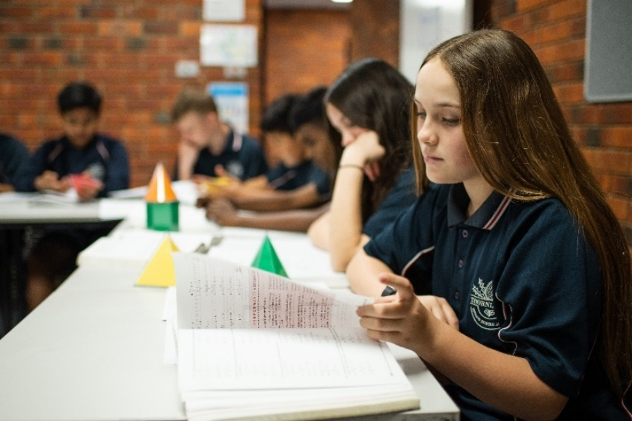
SCIENCE

In the Science Learning Area, students learn to investigate, understand and communicate about the physical, biological and technological world and value the processes that support life on our planet. Science helps students to become critical thinkers by encouraging them to use evidence to evaluate the use of science in society and the application of science in daily life.

Science is compulsory and all students will study Science for four (4) periods per week for the year. Students may also select one of the specialised electives for two (2) periods a week if desired.
Science Science

SCIENCE - 9SC
All science students follow a program developed around the four content strands of the Australian Curriculum: Earth and Space Science, Chemical Science, Biological Science and Physical Science as well as the process strands Science as a Human Endeavour and Science Inquiry Skills.
Special programs have been developed to:
- accelerate selected groups through the curriculum to enable them to enhance their scientific skills and knowledge in the different science disciplines.
- consolidate other groups by allocating more time on process skills and mastering concepts of science. Such a group has limited numbers to allow teachers to give more individual attention.
- All students have the opportunity to move between these programs.

SCIENCE ELECTIVE SUBJECT

The Science Learning Area offers an elective Science unit for those wishing to do further studies in Science in addition to the above compulsory unit.

For the student to be enrolled in their selected electives, any elective costing more than $70.00 must be paid in full when paying the 50% minimum of the total subject costs. If the balance is not paid prior to the commencement of the school year, the student may be moved into a low-cost elective class.

STEM ELECTIVE - 9STEM
The aim of the course is to allow students to integrate and apply their science, technology, engineering and mathematical (STEM) skills. Project based inquiry learning is used to develop their capabilities in these areas.
Throughout the course, students will collaborate and work effectively in teams. They utilise their communication, time management and leadership skills to produce innovative solutions. Students will use current technology to design, create, program and test robots, animations and game applications to respond to their commands, overcome obstacles, and complete set challenges. They will build on their understanding of electrical and mechanical scientific concepts, while computing accurate solutions using mathematics. They will practice creative thinking, with analytical and problem solving skills to engineer solutions to real world problems.

Select groups will participate in the State Robocup Junior and First Lego League competitions using our LEGO Mindstorms NXT robots, with the possibility to compete on a National level. They will also be building and testing solar vehicles, sponsored by the STELR Program, an initiative of the Australian Academy of Technology and Engineering, and the Australian Power Institute.

The course aims to build on students’ interest in STEM and highlights the widening range of education pathways and career opportunities in these fields. Many industries are becoming more focussed on innovation and creativity, which will be fostered in this course. There will be exposure to industry and university experts who will present the latest technologies to the students. This course exposes them to computer science, engineering and ICT career pathways.
TECHNOLOGIES

In the Technology and Enterprise Learning Area, students apply knowledge, skills, experience and resources to the development of technological solutions that are designed to meet the changing needs of individuals, societies and environments. Students become innovative, adaptable and reflective as they select and use appropriate materials, information, systems and process to create solutions that consider the short and long – term impact on societies and environments.

For the student to be enrolled in their selected electives, any elective costing more than $70.00 must be paid in full when paying the 50% minimum of the total subject costs. If the balance is not paid prior to the commencement of the school year, the student may be moved into a low cost elective class.

The Technology and Enterprise learning area comprises three departments – (i) Digital Technologies and Business, (ii) Design and Technology, and (iii) Home Economics.

DIGITAL TECHNOLOGIES AND BUSINESS

FLASH ONE - 9FO
This course is designed around Multimedia applications and their uses. Software includes macromedia products such as Flash, Director, Adobe Photoshop, Movie Maker, Sound Studio. Students will create digital photographs, DVD menus, their own sound samples, plug ins for WebPages and simple games. This course is a good introduction to software and basic computing with a hint of the fun stuff. Imagination is required. For future web designers, graphic artists, animators and sound engineers.

SMALL BUSINESS ENTERPRISE - 9SBE
Technology & Enterprise Technology & Enterprise
This course will cover the development of skills in a wide range of study within the business field. In this course, students have the opportunity to plan and develop small business ideas within small work groups, integrating different forms of technology and business processes. Using a combination of theoretical and practical business knowledge and skills, students will investigate, plan and evaluate business ideas. The real-time viability and success of their business ideas will depend on their ability to work collaboratively in a team in a simulated business environment. This is an excellent subject to introduce students to the real world of how small businesses start up and evolve. This course is perfect for motivated students with creativity, imagination and a can-do attitude.
Technology & Enterprise Technology & Enterprise
COMPUTER PROGRAMMING - 9CP
A pathway to Year 10 computer programming, computer science and applied information technology
Technologies Technologies

Understanding of computer programming, databases and game creation is a useful skill to have in this day and age. Computer Programming covers the basics of programming and is a good lead up to the computer science course in Years 11 and 12. This course covers basics such as HTML, Python, Java Script and networking basics. Basics of databases and design will also be covered. In this subject students will be writing code for both webpages and game creation. Hardware and networking devices will also be covered to give students an overall grounding in information technology and how the world really works.

The course focusses on the practical creation of programs and games but also the grounding of theory and problem solving to encourage these skills to progress in further years. Students will need good problem-solving skills, logical thinking and the acceptability of new ideas is necessary. Students will create programs, web-sites, databases and network security solutions that incorporate real world skills.
Technology & Enterprise Technology & Enterprise
Technologies Technologies

DESIGN AND TECHNOLOGY

ENGINEERING SYSTEMS - 9ES
This course is designed to give students experiences and skills in a broad range of Engineering Systems. Students will learn practical skills in Welding (Arc, MIG & Oxy/Acetylene), tool maintenance, manufacturing, and machining. Students will also learn small engine theory, maintenance, and repair procedures. This course will give the student an opportunity to make a range of interesting and useful projects as well as working on their engines. There is a strong focus on Occupational Health & Safety for all students and is relevant to anyone who is planning to apply for a trade apprenticeship in mechanical or metals engineering.

MATERIALS TECHNOLOGY - 9MAT
Materials Technology is about students making a range of interesting projects that build on skills introduced in the Year 8 course. Many of the designs are craft orientated and encourage students to use a variety of materials including wood, metals and plastics either separately or in combination. Students will also learn how to safely use workshop equipment such as woodworking and metalworking lathes, bending equipment, electric drills, jigsaws, finishing machines, electric sanders, oxy-acetylene equipment and buffing machines. This course has a strong focus on design, safety and the enjoyment that comes from making a range of attractive and useful projects.

MATERIALS WOOD – 9MW
This course is aimed at those students who have limited or no experience in Year 8 Woodwork but wish to attain the necessary background to enrol in Materials Wood at Year 9 level. Students will learn how to safely use a range of workshop equipment such as wood lathes, electric drills, bandsaws, finishing machines, electric sanders etc. Students will also use equipment associated with staining and spraying finished pieces. This course has a strong focus on design, safety and the enjoyment that comes from designing and making a range of interesting projects. Students who wish to extend their knowledge and experience further in this area should choose the Woodwork course for future Year 10 studies.

TECHNICAL GRAPHICS - 9TG
This course has a strong emphasis on applying computer technology in teaching and developing skills in drafting and technical illustration. The learning opportunities in this course have a direct relevance to the skills required by industry, TAFE and universities. The primary areas of study in this course are:

- Architectural and Mechanical Drawing
- Pictorial Drawing and Technical Illustration
- Rendering of Drawings

- 3D modelling software
- Introduction to AutoCAD – Industry standard Computer Aided Drafting software

Students will produce a folio that includes computer-generated drawings as well as sketches, illustrations, and designs for a range of different tasks. This course is highly recommended for students looking to develop a career in Drafting, Engineering and/or Architecture.

HOME ECONOMICS

CHEFS JUST FOR YOU - 9CJY
Become a Chef or just learn to create food that others will love to eat. The choice is yours. This course is designed to give students an opportunity to see and experience food creation from the perspective of the food and catering industry with an emphasis on final presentation. There is a high practical content, with a focus on restaurant and “café style” food. Students will also learn about menu planning, incorporating a variety of different cuisines to meet individual needs in a variety of situations. Students will be exposed to and will prepare a wide range of dishes representative of different countries and gain a better appreciation of various cultures.

FABRIC CREATIONS - 9FC
During this course, students will explore various textile styles and influences to discover their own personal flair and create work inspired through self-expression. Students will gain practical skills and experience in producing original designs using a variety of mediums.

Students will have the opportunity to produce their items with environmental considerations using techniques such as upcycling, machine embroidery and contemporary crafts. An excellent foundation for fashion or interior design.

Students will be required to provide fabric for personal items during this course.

